¡Me gusta! ¡No me gusta!
Read each new food word below. Point to the face that describes your opinion of that food and give the response in Spanish! Example: Me gusta la manzana.
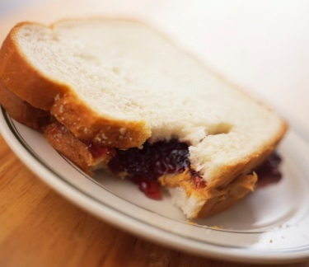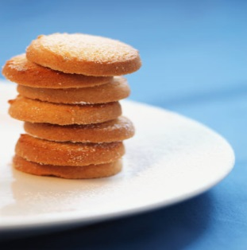
El refresco sándwich las galletas

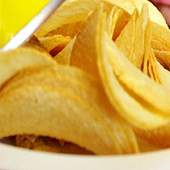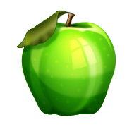

las papas fritas el jugo la manzana

Extra practice: Find these foods in your kitchen and practice saying the word in Spanish!

