¡Vamos a comer!
Class Times and Dates:
8-8:45 Mondays
10/6, 10/13,
10/20, 10/27,
11/3, 11/10, 11/17, 11/24
Information

Here are some new words we have learned that you can practice at home:
Frutas- fruit
Manzana- apple
Plátano- banana
Fresa- strawberry
Uvas- grapes
Naranja- orange
Limón- lime
Mango- mango
Piña- pineapple
Mercado- market
Ensalada de frutas- fruit salad
¡Vámonos!- Let’s go
Me gusta- I like
No me gusta- I don’t like
Vamos a comer- Let’s eat
Amigo- friend
Primos- cousins
¡Jugamos!
Today we met Beto and Dani, who are funny and adventurous cousins from Mexico. They are our puppet mascots for class. We played games like Manzana Caliente and Mata la Mosca.
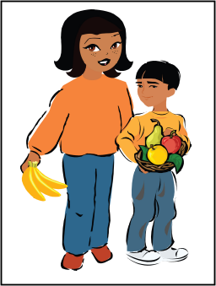

Vocabulary List

Welcome to the first week of the theme based Spanish class called “Vamos a Comer.” Today we went on an adventure with Dani and Beto and learned about fruit in Spanish! Please contact Futura Language Professionals or me with any questions about Spanish class. Teacher information:

Music
¡Vamos a Comer! (This is our class theme song. Sing to the tune of the Farmer and the Dell)
Vamos a comer
Vamos a comer
Toda la clase, vamos a comer
A mercado is an open air “store” where vendors (individual people) sell items to make money. They sell all kinds of things like fruits, vegetables, meat, clothes, house wares and sometimes even live animals! At the market the vendors don’t usually have a set price for items like in the grocery store. The vendor typically says one price and then the person who wants to buy the item says a lower price. They keep going back and forth until they agree on a price. This is called bartering.

Here are a few websites to practice what you have learned today! http://www.languageguide.org/im/fruits/es/ Note: The students didn’t learn all of the words; however, they can practice the ones they did.
http://www.studyspanish.com/vocab/games/fruitsp-flashcards.htm

Notas Culturales
Internet Suggestion/Practice at Home

