La familia
Directions: Draw a line to match the family vocabulary to the pictures below.
**Parents: For nonreaders, please help your student do homework orally.

La madre
El hermano
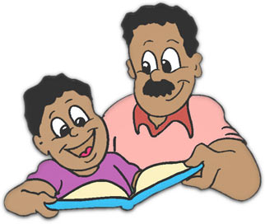
La abuela
El padre
El abuelo
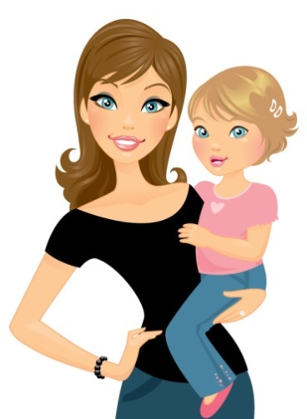
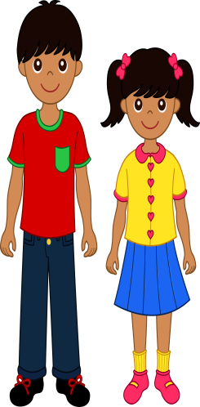
La hermana

Extra! Practice conversation with a family member by asking his or her name in Spanish by asking:
“¿Cómo te llamas?”
Also, ask how he or she is feeling using the Spanish phrase:“¿Cómo estás?”
Teach your family member the correct responses in Spanish: muy bien, bien, más o menos, mal, y muy mal.

