El Partido de Fútbol

Directions: Draw a line from the image to the correct word. Some images may be used more than once. *If your child does not yet read, say the Spanish word out loud and encourage your child to point to the corresponding picture.
bloquear

La Pelota

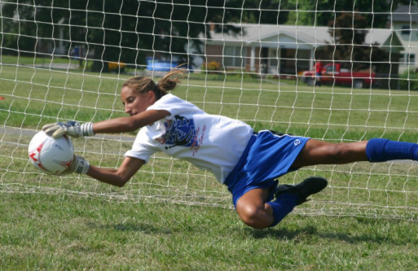
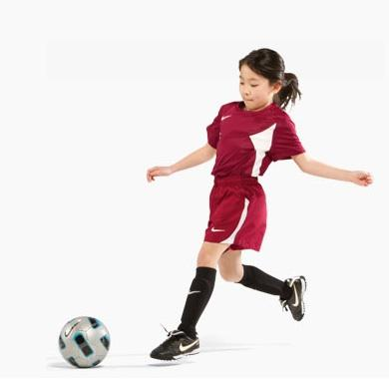
Jugar fútbol

¡gol!

Patear

El equipo

