Paper Coquí
Courtesy of http://learncreatelove.com/printable-tree-frog-craft/
Thank you Learn Create Love for this great craft idea!
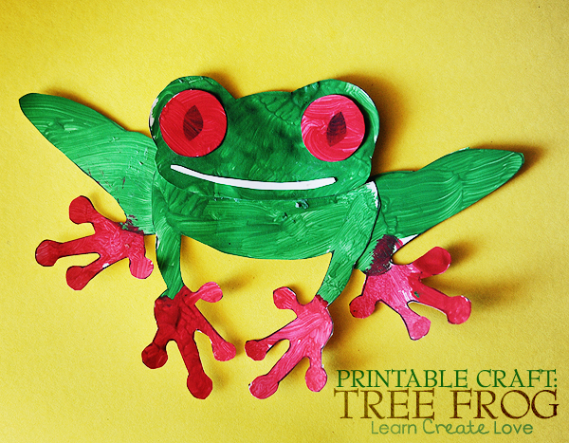
What You Need:
- Sample pictures of el coquí to show the students (refer to the talking points sheet)
- Print the printable of the frog (separate document) (One for each student)
- Coloring materials such as crayons, markers, colored pencils
- Glue/Stapler (One for every two students)
- Construction paper (large enough to fit the frog)
- Scissors* (One for every two students)

What You Do:
- Show the students the various pictures of the samples of el coquí and talk about what some common colors are in them.
- Say the colors together in Spanish.
- Explain to the students that they are going to make their own coquí.
- The students will color the sheet carefully.
- Then they will cut out the pieces if necessary and assemble them together.
- They can glue or tape the frog pieces onto a piece of construction paper.
- Students will glue the finished coquí image onto the construction paper.
- Have each students label the picture with Me llamo el coquí. Vivo en Puerto Rico. Write these phrases up at the board for reference and teach the students what they mean. Practice with repetition as the students are working.
- After they are finished, have the students sit in a circle and practice saying their own names with the “Me llamo” and where they live with “Vivo en” conversation elements.

