We hope you enjoyed the first day of Spanish class! Thank you for your efforts in practicing what you have learned in class with this optional homework. Enjoy!

Today we practiced how to introduce ourselves in Spanish. Practice saying this with your friends (amigos) and family. See if you can teach them to say their name in Spanish too!

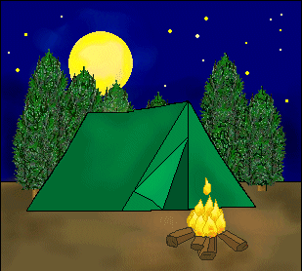
Me llamo________________________. My name is______________________.

El Campamento

We had fun learning vocabulary and conversation in Spanish that can be used at “el campamento” (the campsite). Practice this vocabulary by creating picture flashcards below. Draw pictures to represent the words below from the camping adventure and have the word written in Spanish on the back side. Note: Reference the newsletter for translations. This is great way to practice the vocabulary from class. One way to practice would be to look at the word and see if you remember what it means in English. Then flip it over to see if the image matches. Challenge yourself to look at the image and say the Spanish word for it. You can flip over to check if you are correct. Use the picture flashcards to teach your friends and family members the new vocabulary too!

Word Bank: el campamento, las mantas, una bolsa, la camisa, la fogata, los palos, el saco de dormir

