***Vamos a Acampar* Abbreviated Lesson Plan: Day 5**

**Target Vocabulary: *El parque de la cascada***

|  |  |  |  |
| --- | --- | --- | --- |
| *la cascada* | waterfall | *los árboles* | trees |
| *las flores* | flowers | *yerba alta* | tall grass |
| *el lagarto* | lizard | *el pájaro* | bird |
| *el oso* | bear | *las montañas* | mountains |

**Builder phrases to emphasis:** ¿Qué ves____?; Yo veo____ Necesito_____

**Materials needed:** Flashcards (2 sets from this week and last) with the target vocabulary; As many real props as possible! For Day 5, you can bring plastic flowers, a toy lizard, bear, bird and extra pictures. Also, bring items from Day 4 if possible. Puppets, 2 print outs of the camper image, map, flashlight, bandana, binoculars and bags OR materials for *binoculares* craft activity (see Repaso activity options below), the picture of Ana María, notas culturales items (Torres del Paine National Park); materials for the Stations, materials for *La Cascada* review game.   
  
**You:** Early and prepared with items you need lined throughout the class lined up in order. This class has games that require you prep the classroom. If you want to make it really fun, dressed as a park ranger or hiker for the camping theme!  
  
**Vobulary Instruction Methodology:** TEACH the vocabulary; REINFORCE the vocabulary; CHECK IN for vocabulary retention. I. Have Spanish music playing as the students enter the room.

II. Greet each child as they enter the room. ¡Hola! ¡Bienvenidos! Ask them their names in Spanish and mark it on the attendance document. Be sure to give each child their name tag at this time. (Follow up on attendance as needed)

III. Have the class sit in a circle on the floor, and greet everyone with a lively *¡Buenas tardes clase!* Reinforce ¿Cómo te llamas? Me llamo___ by first introducing yourself. Then have a maraca or a ball or similar to pass around the circle and have each child ask and answer the question. Then say ¡Mucho gusto! Nice to meet you! Check in and ask what ¿Cómo te llamas? Me llamo___ mean.

IV. Stand and sing your chosen greetings song using gestures (Ex: “Hola amigo, ¿Cómo estás?...”)  
  
V. Sit back down in the circle

VI. Review the rules by having the class participate in saying each rule.

VII. Remind everyone that they currently have three *estrellas* and that if they have all three *estrellas* by the end of class they can get a sticker or a peso. (*Be sure to have a system to save the pesos or track them. Also, it is a good idea to have a collective place for the students to collect stickers like a name tag, folder, or pre-designed certificate.)

IV. Bring out Dani and Beto and ask the students in Spanish if they remember their names. Encourage them to greet them with, “¡Hola Dani y Beto!”

V. Remind the students that Dani and Beto are camping (a acampar). Have the class say with you, “¡Vamos a acampar!”  
  
VI. **Theme song**: Stand and sing the theme song with gestures*.   
***Vamos a Acampar*** (Sing to the tune of the Farmer in the Dell)

*Vamos a Acampar*

*Vamos a Acampar*

*Con mis amigos, voy a acampar*

*\* You can have an “alternate” way to sing the class theme song-like a chant for example. Especially for older students, this can be a make-it or break-it first impression of the class!*A fun alternative is to teach it as an interactive chant.

For example:

Teacher: Vamos a…

Students: Acampar!

Teacher: Vamos a…

Students: Acampar!

Teacher: Con

Students: MIS AMIGOS

ALL: Voy - a Acampar!

VII. Review the vocabulary from last week:

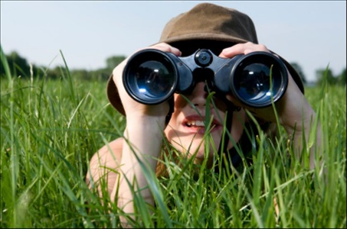 ¿Qué ves? – Using two printed copies of the intranet pictures of the campers, divide the class into two teams *Equipo Dani y Equipo Beto.* Teams sit in circles working together to identify what they learned last week. If they can, they can circle and label the objects on the pictures; for younger students, they can just circle and then present what they remember. This is a race! The fastest team wins. Then the teams take turns reviewing what they see in the pictures by asking “¿*Qué ves*?” and responding with the right vocabulary by starting with “*Yo veo*…”. Make sure the entire class repeats the right answer together. For tips, refer to the full length lesson plan.  
  *Binoculares*- Hold up binoculars or pictures of these and ask the class “¿*Qué es esto*?” Reward students who get the right answer and have the class repeat the correct answer. Explain that Dani and Beto need our help on the trail- they need *los binoculares* to see better! **Have the students make their own binoculars (for a large class, pair students up for one set of binoculars). Materials: Empty toilet paper rolls, string, glue, hole punch. See full length lesson plan for instructions.

**You can also have the kids imagine they are creating their *binoculares* by just making a circular shape with their hands around each eye. This will help you limit the time spent on this activity. The craft activity is also really fun, but be sure to limit it to 5-7 minutes by having all the materials ready.

VIII. Teach the new vocabulary: Gather the students back into the circle. Pull out Dani & Beto and your flashcards and/or props. Make sure all the students get a chance to repeat the new words at least three times  
Dani: *Estamos en “la sorpresa”, Beto.* We are at the surprise Beto*. ¿Qué ves?* What do you see?

You: Have a picture of a waterfall covered with a piece of black construction paper. Have a volunteer play the part of Beto to uncover the surprise.  
Beto: *¡Ay! ¡Es increíble!* Incredible! *Es* ***una cascada****.* It is a waterfall.

You: *Clase, repite por* *favor, una cascada.*   
Dani: *La naturaleza en este parque es muy bonita.* The nature at this park is so beautiful.   
Beto: *¿Qué ves?*

Dani: *Yo veo* ***los árboles*.** I see the trees.

Beto: *¡Yo veo una chica!* *surprise*

Ana María: *¡Hola! ¿Qué pasa?* Hi! What´s up? (Hold up the picture of Ana María)

Dani: *Hola. Estamos bien.* Hi, we are good. *¿Y tú?* And you?

Ana María: *¡Estoy muy emocionada!* I am very excited! *Me encanta la cascada y toda la naturaleza.* I love the waterfall and all the nature.

Beto: *Yo soy Beto y ella es mi prima Dani.* I am Beto and she is my cousin Dani. *¿Cómo te llamas?* What is your name?

Ana María: *Me llamo Ana María y soy de Chile.* My name is Ana María and I am from Chile. *Estoy aqui para unas vacaciones.* I am here for vacations.

Dani y Beto: *Mucho gusto.* Nice to meet you.

Ana María: *Debemos ver la naturaleza con los binoculares.* We should look at the nature with binoculars.

**If the students have made binoculars, have them hold them up!

Dani y Beto: *¡Sí!*

Ana María: *Yo veo* ***el pájaro****.* I see a bird. (Show picture or prop of bird, have class repeat vocab)

Dani: *Sí, y yo veo* ***el lagarto en el sendero****.* Yes, and I see the lizard on the path.

Beto: *Yo veo* ***las flores****.* I see flowers.

Ana María: *Yo veo* ***la yerba alta*** *allá.* I see the tall grass over there.

Dani: *Miren* ***las montañas****.* Look at the mountains.

Beto: ¿Creo que veo…? ¡***Un oso****!* I think I see…a bear!

Dani: *¡Un oso! ¡Qúe susto!* A bear! How scary!

Ana María: *No Beto, no hay un oso, pero a mi me gustan mucho los osos.* No, Beto. There is no bear, but I like bears.

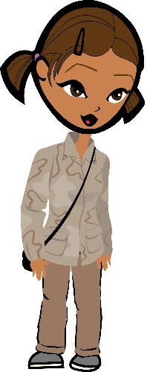Beto: *¡Qué divertido!* How fun! *Me gusta nuestra nueva amiga.* I like our new friend.

IX. Reinforce the vocabulary: Move to a different area of the room and have the students sit down. In the circle hold up the objects and/or the flashcards again and have each student repeat the words after you. Speed it up as they start to remember to make it more fun.   
  
IX. Check in to see if the kids know the vocab: Lay out the objects/flashcards. (You can include the items from last week too.) Call out a vocab word in Spanish by saying the builder phrase Yo veo+ the object and have volunteers point to the corresponding object. Alternatively, you can hold up the objects/cards and have the students say the words when you ask ¿Qué ves? and they answer Yo veo + the object. *This is a very important step before moving to a game.*

X. **Juego**- *Yo veo* (I spy): You will need the picture flashcards of the nature vocabulary posted around the room. Students will sit in the center of the room. If they have made *binoculares*, have them use them, or they can pretend by using their hands around their eyes. Make the students use their *binoculares* to find the things in nature that they have just learned as you are describing them. The students must *levantar la mano* when they think they know what you are describing. If they are correct in guessing, he or she can pick the next item to describe. Start with “*Yo veo*…” Your descriptions should be in Spanish with English translation.

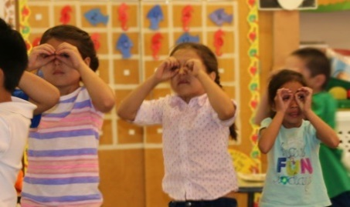

*Variation: For a hands-on version, the students can stand and then run to the posted picture of what you are describing. The first to arrive can help you describe. For a new word, all the students start back up at the center.

Remember to have everyone repeat the word once the correct word in Spanish.

*** Remind the students of our expectations of respect for each other and the classroom for this activity to work.

Please refer to the full length lesson plan for tips on how to make the game work best.

XI. Puppet time:Regroup the students by using the attention getter.

Ana María: *¿Dónde está el pájaro?* Where is the bird?

Dani: *No sé. Debemos buscarlo*. I don´t know. We should look for it.

Beto: *¿Y dónde están las flores?* And where are the flowers?

You: *Vamos a ayudar a Dani, Beto y Ana María para buscar las de la naturaleza con una actividad divertida.* We are going to help Dani, Beto and Ana María find the things in nature with a fun activity

Alternate juego/reinforcement activity: Divide your class into teams *Equipo Dani y Equipo Beto.* Each team will work together to complete a scavenger hunt. You will hide a picture of each vocab item around the room, along with a clue for the next item and location. Be sure they are in the following order: *las flores, los árboles, el pájaro, el lagarto, el oso, la yerba alta, las montañas, y la cascada.* See full length lesson plan for tips and variation on the game.

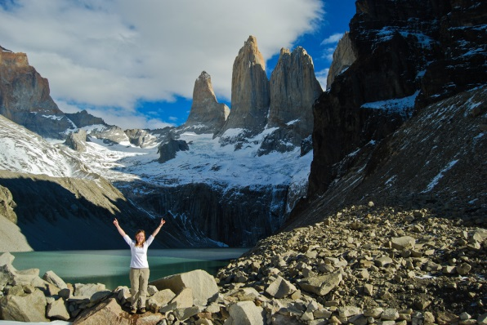**XII. Merienda Y Notas Culturales:** Have the students get their snacks and go sit at the table quietly while you teach the culture portion of today’s class. Remember this cultural part is not optional! You will now initiate a discussion about Chile. Explain that Chile is in South America. Chile is a very long, narrow country so the country has everything: mountains, deserts, beaches, etc. If you can, have them find it on the map. One of the most interesting regions is called La Patagonia. La Patagonia stretches into Argentina as well, but since Dani and Beto´s new *amiga* is from Chile we are going to focus on Chile today. In Patagonia there are actually glaciers and islands everywhere! One of the most popular places to hike in Chilean Patagonia is Torres del Paine National Park. Even though the weather can be very dramatic, people from all over the world come here to hike and to see waterfalls, glaciers, rivers, lakes and lagoons. Every summer humpback whales can even been seen here! Did you know that the seasons in Chile are the opposite of our seasons? That means when it is December here, it is summer in Chile! However, Patagonia is a cold place! You must have special clothing and sleeping bags to camp in Patagonia. You can hike, boat, kayak, and fish in this region. It would take at least two days to see this park hiking. Ask if they would like to visit there someday by having them answer Sí or No. 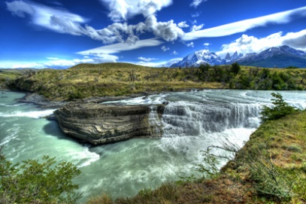

**Cleanup:**  Give the students a warning to clean up. After 5 minutes all snacks need to be put away. March back to the circle as a class singing the theme song.   
  
**XIII.** *Actvidad: El parque de la cascada*

Puppet time:

Ana María: *Me gusta el parque de la cascada.* I like the waterfall park. *¡Debemos explorar más!* We should explore more!

Dani y Beto: *¡Clase, ven con nosotros!* Class, come with us!

**Cantamos y visitamos:**

You will choose three stations to set up before class for this virtual field trip. The stations are described below the song. The students will follow you to each station. In between the stations you will teach and sing the following Bear Hunt song with gestures. You should move together, using the song as a transition from place to place and as a way to keep them moving together.

NOTE: This may run longer than 5-7 minutes total, but that´s okay. The station changes from activity to activity in the virtual trip will help keep interest high. Do be aware, however, that you may need to sit at some stations or encourage students to dance when there´s music to keep them from becoming distracted or restless. Just remember: change it up and give them plenty of opportunities to wiggle!

**Vamos a la caza de oso (To the tune of Going on a Bear Hunt)**

Vamos a la caza de oso (show picture of bear)

Vamos a capturar un oso grande (make large gesture)

No tenemos miedo (acting tough)

Uh Oh ¿Qué es esto?

Hierba alta (Show picture)

No se puede subirla (raise hands high for over motion)

No se puede bajarla (lower hands for under motion)

Tenemos que pasarla (put hands forward for through motion)

Swoosh, swoosh, swoosh (with gestures of walking through tall grass)

**\*Start Station 1**

Vamos a la caza de oso (show picture of bear)

Vamos a capturar un oso grande (make large gesture)

No tenemos miedo (acting tough)

Uh Oh ¿Qué es esto?

El lago (show picture)

No se puede subirla (raise hands high for over motion)

No se puede bajarla (lower hands for under motion)

Tenemos que pasarla (put hands forward for through motion)

Splash, splash, splash (with gestures of swimming)

**\*Start Station** 2

Vamos a la caza de oso (show picture of bear)

Vamos a capturar un oso grande (make large gesture)

No tenemos miedo (acting tough)

Uh Oh ¿Qué es esto?

Los árboles (show picture)

No se puede subirla (raise hands high for over motion)

No se puede bajarla (lower hands for under motion)

Tenemos que pasarla (put hands forward for through motion)

Trip, stumble, trip, stumble

**\*Start Station 3**

**Hide the bear prop/flashcard in Station 3 so they can find it!**

**Choose 3:**

1. Nature Mural: Have a large white piece of paper on a table or taped to the wall. Encourage the students to work as a team and create a mural or painting of the waterfall park with the new vocabulary they have learned from class today.

*Make sure to keep this activity to 5-7 minutes and encourage the students to work quickly so that you can continue the adventure!

2. Juego: Sort/Scramble- For this activity, you will need a set of vocabulary clip art from this unit for the lake, the campsite, and the food on index cards. Challenge your students to correctly sort them into three sboxes or bags el lago, el campamento, y la comida. You may want to make this a race between two teams. Have three boxes with a picture of the topics above. The players will race to put the related flashcards in the correct boxes. You may also want to review the words beforehand to ensure this activity is a success.

3. Pescar las preguntas- In this activity the students will each get a turn to fish out a question from a bowl of water, representing un lago. For this activity you will need: two bowls of water, zip lock bags, and slips of paper with the questions written on them. Please be sure to prepare and set this up prior to class starting. Place the question inside the zip lock bag and then put it into the water bowl. Students use their hands to fish out the question and answer it. You can have two bowls set up and divide the class into two teams. Questions can range from any of the topics covered this semester so far.

4. *Binócular* photo: Post the nature mural up on the board. Have a desk or table set up below it for this station. When the students come to the station, ask them to bring their binoculares. If you have a digital camera, take actual pictures of the kids standing in front of the mural wearing their binoculares to give to the parents at the end of the semester.

XV. Juego de repasar: **La Cascada de Preguntas**. Using blue yarn or drawing blue lines, have Equipo Dani and Equipo Beto take turns choosing envelopes from *la cascada* you have created. Using a board or the board in the classroom, attach envelopes to the end of the blue yarn or drawn lines with tape. Each envelope has a strip of paper with a question. The teams take turns answering the questions in the envelopes. Each correct guess earns a point for the team.

XVI. Wrap up: **Puppets’ Despedida**

Dani: *Tengo sueño.* I´m tired (yawn)

Beto: *Yo también*. Me too.

Dani: *Buenas noches Beto.* Goodnight Beto.

Beto: *Buenas noches, Dani*. Goodnight Dani.

**\*\*Last 5 Minutes of Class:** It is VERY important that the last 5 minutes of class be organized. This is most likely the only part of your class that parents will see.

Ending routine:   
-Have the students grab their backpacks and return to the circle on the floor. At this time you can distribute newsletters (on colored paper) and the optional homework.   
-Show the parents at the door something the kids learned. A great way to end is for each student to tell you a “word of the day” using a builder phrase from this or last week. For example, “*Veo un pájaro*” or “*Necesito mis binoculares*”

-Teach the goodbye song standing and with gestures.

Filing out:   
-Stand at the door and have the class stand in a single file line. Do not let anyone get ahead of you. As the students see their parents, greet the parents and introduce yourself.   
-Say good bye and thank you in Spanish as each child is matched with a parent.   
-Walk the kids who are in after school to designed after school location

-Return to your room to clean up.

***Remember, YOU are the face of Futura in the classroom- thank you for making this a great class!***