Week 8 Optional Homework
¡Felicidades! Congratulations! You have learned mucho vocabulario in your travels with Dani and Beto. Let’s review!

All of the Spanish words for the items below start with the letter “p.” Can you name them? Hint: use your newsletter(s) or the answer key at the bottom of the page for help!

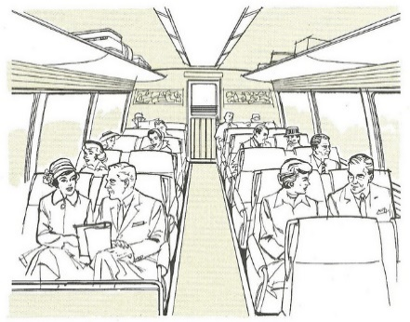
_______________ ______________ ________________ ____________________

Find out which color crayon to use on each picture by reading the Spanish phrase below it. Then, have fun coloring!

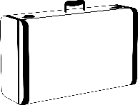
el lago azul el autobús amarillo el taxi rojo la maleta verde

Write (or talk!) about your favorite game or activity from this semester’s traveling adventure. Use the lines below.
Mi juego favorito fue… (My favorite game was…)
________________________________________________________________________________________________________________________________________________________________________________________________________________________________________________________________________________________________________________________________________________________
¡Buen trabajo! Good work!

