Practice using the correct form of THE in Spanish with some of the vocabulary words from today’s lesson. Feel free to use your newsletter for help!
Fill in EL, LA, LOS or LAS (answers are at the bottom of the page)
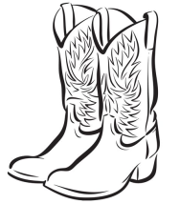 ________________________ botas
________________________ sombrero
________________________ tía
________________________ tío
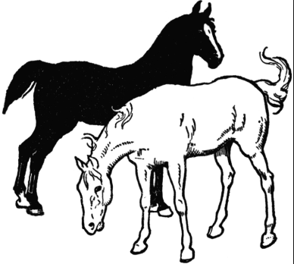 ________________________ caballos

