Me llamo___________________________________
Week 3 Optional Homework: Vamos con la familia
El mercado
Directions: Color the items below from the market and label them in Spanish.
Verde= green, rojo= red, azul= blue, negro= black, amarillo= yellow
Camisa, bolsa, zapatos
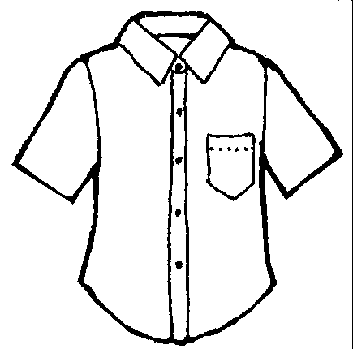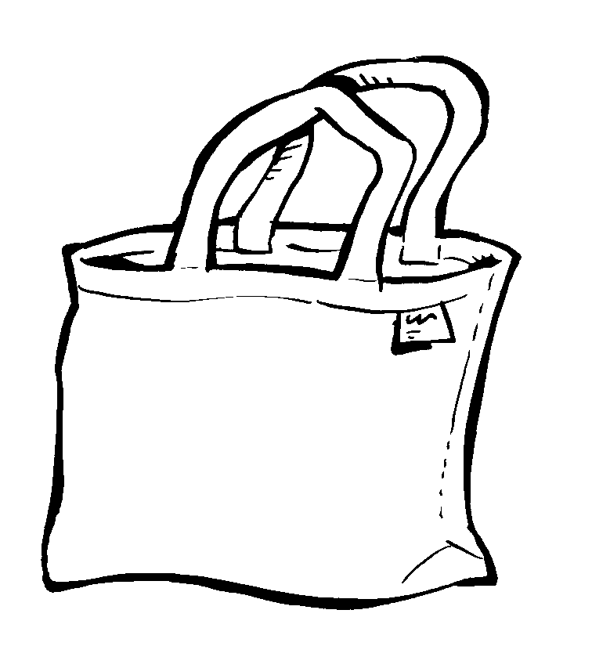

¿Qué necesitas? (What do you need?)
Directions: Write three sentences to describe the items you need from the from the market with class vocabulary in Spanish using the phrase “Necesito____.”Note: You can use vocabulary from previous weeks as well. For example: Necesito las botas. I need the boots.
Tell a friend or family member the three sentences orally in Spanish.
- _________________________________ .
- __________________________________.
- __________________________________.
Futura Language Professionals · www.futuraadventures.com

