Day 5- Optional Homework
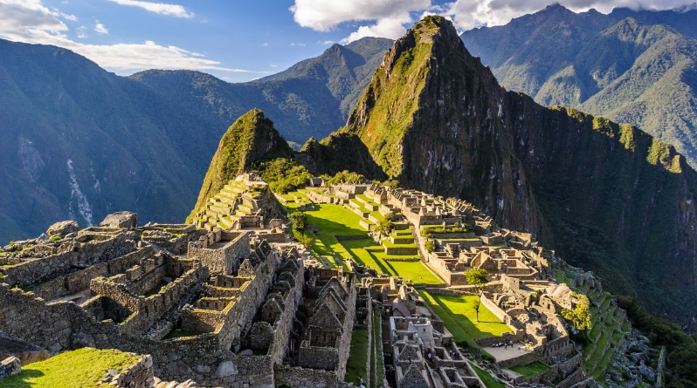
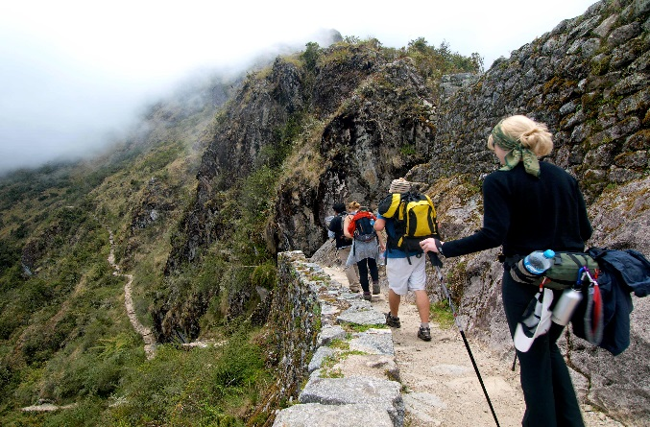
Hoy fuimos a Machu Picchu! Today we went to Machu Picchu!

las botas temprano el suéter la cámara
estoy cansado los lentes de sol el agua la mochila

Directions: Use the word bank and picture clues to write the Spanish words that makes the most sense with the statements below. Use your newsletter for help!

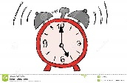
Me levanté a las 5 de la mañana para ver el amanecer sobre las ruinas incas. I woke at 5am to see the sunrise over the Incan ruins.

____________________________ _____________________________
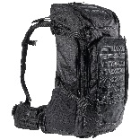
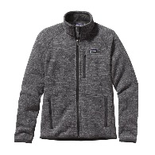
Necesito muchas cosas en Machu Picchu. I need a lot of things in Machu Picchu.

____________________________ __________________________________

 

