Day 7- Optional Homework
Hoy, nos desayunamos en La Plaza de Armas en Arequipa, Perú.
Today, we are eating breakfast in the Plaza de Armas in Arequipa, Peru!
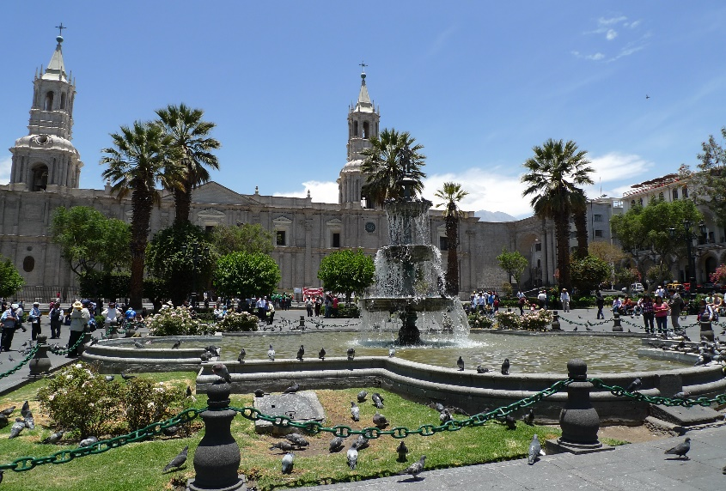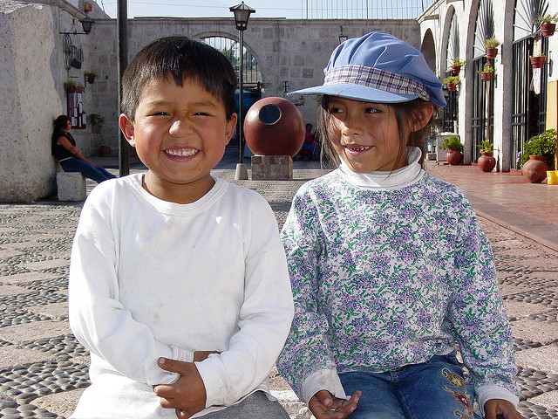
Directions: Draw la comida (the food) on the plate below. Draw a line from your drawings to the vocabulary words. There is even a special dessert included!
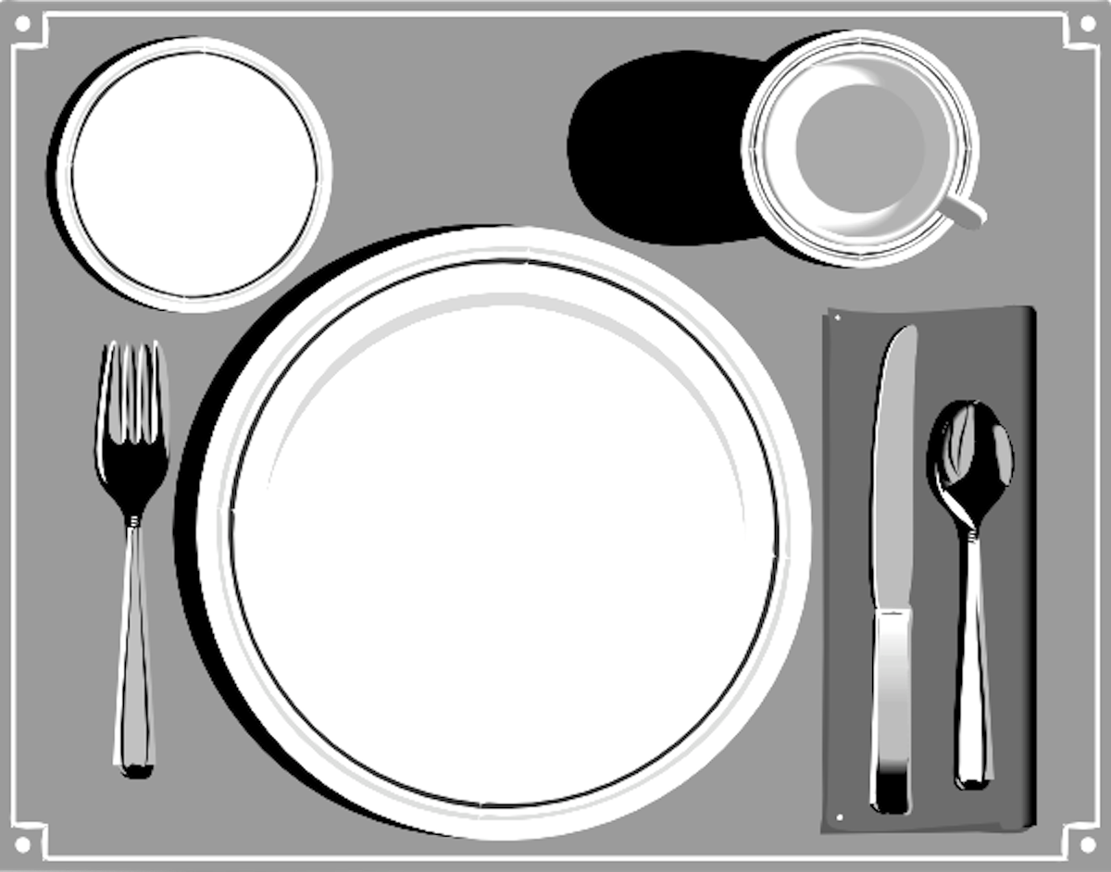

el pan

los huevos
revueltos

el jugo

el helado

*Más Práctica: Practice your Spanish aloud by using, “Me gusta/n…” or “No me gusta/n…” with the foods above.

