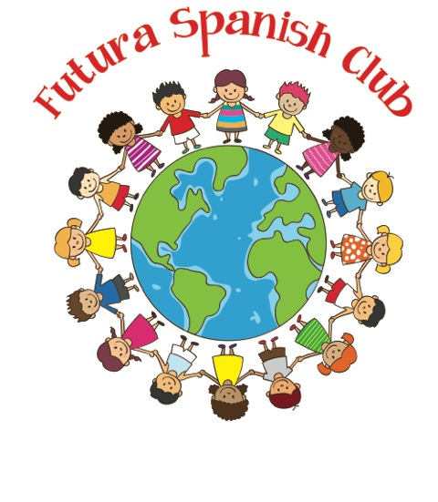

Week 4
Spanish Newsletter

¡Vamos con la Familia!
Futura Language Professionals
www.FuturaAdventures.com

primo(a) cousin
alto(a) tall
bajo(a) short
amable nice
la falda skirt
el helado ice cream
Me gusta(n)… I like…
¡Ven acá! Come here!

Vocabulary List
Today in class the kids joined in celebrating a festival in Cuzco, Peru! On this adventure we met Cousin Arturo. We played interactive games to practice describing the vocabulary,
adjectives, and colors we
have learned in Spanish.

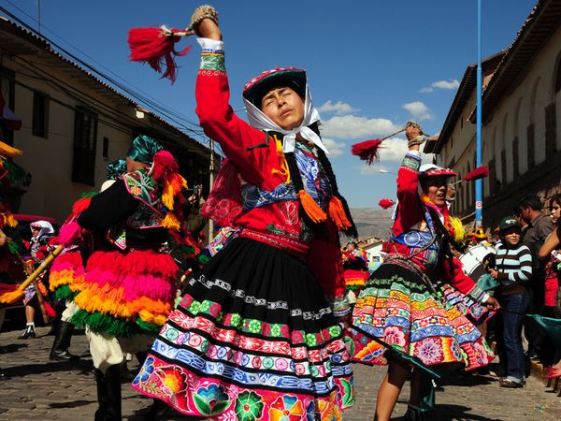

Practice at Home

Draw a line to any of the images below that can be used with the phrase
“Me gusta…”




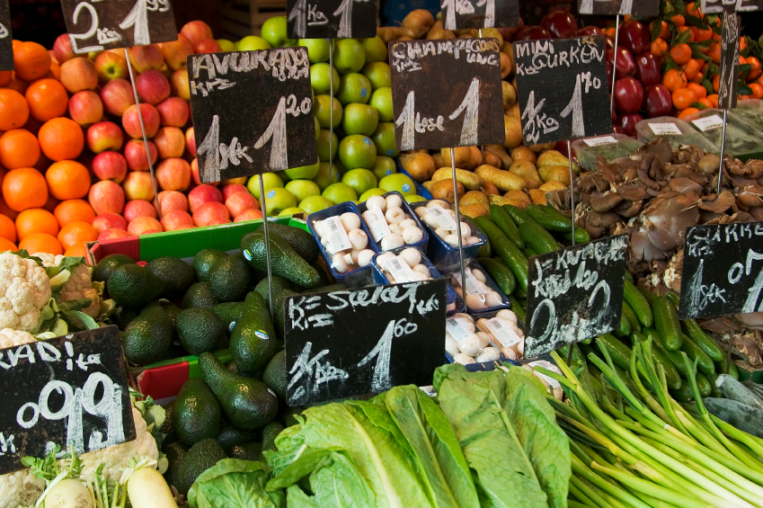

…el caballo …el helado …la familia …el mercado

Notas Culturas/ Internet Suggestion
Did you know? Cuzco, Peru was the heart of the Incan civilization. The Incas were the native population that lived in Peru 800 years ago like the Native Americans of the United States. Many descendants of the indigenous Incan population still live in Peru today.
Cuzco is known for its many festivals during the year. Many music and dance groups perform wearing hand-woven clothes during the celebrations.

Information
Please contact the Futura Language Professionals Coordinator, SandyO@FuturaAdventures.com with any questions about Spanish class.

