WEEK 4: El Jardín
The words below are in English. Translate them into Spanish using the vocabulary words from Week 4 and then complete the crossword puzzle below.
Note: If you are a parent of a non-reader, show your child pictures of the words below and practice repeating them in Spanish. Sometimes it is easier when a child is just learning to hear the word in Spanish and to give the translation in English, so try that too!
 |  |  |  |  |  |  |  |  | 1 | 2
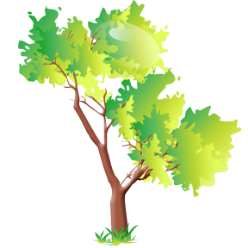
 |  |  |  |  |  |  |  |  |  |  |  |  | 3
 |  |  |  |  |  |  |  |  |  |  |  |  |  |  |  | 4
 |  |  |  |  | 5
 |  |  |  |  |  |  |  |  |  |  |  |  | 6
 |  |  |  |  |  |  | 7
 |  |  | 8 |  | 9
 | 10
11

Down Across
2. Laundromat 1. Flowers
3. Please 5. Fountain
4. I have 6. Tree
7. Thank you 8. To wash clothes
9. Neighbors 11.Garden
10. Bench

