Mi Familia
Fill in the family tree below with your own family or feel free to use your creativity and use a family from your favorite book or movie. You can write the names of the people and draw pictures.
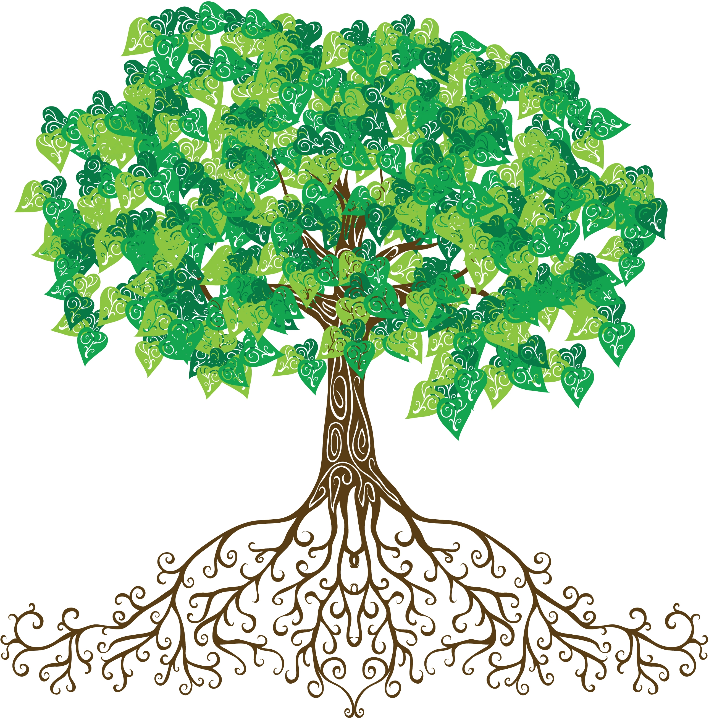
YO
Tía
Tía

Tío
Tío

Hermano / Hermana
Mamá
Primos / Primas
Abuela
Abuelo
Abuela
Abuelo
Primos / Primas
Papá

