Práctica V: Los Números 16-100 Nombre:________________________

Part I: ¡Qué caro! You are shopping at a very expensive store. Use the prices provided to answer the following questions in complete sentences. Spell out the numbers in español.
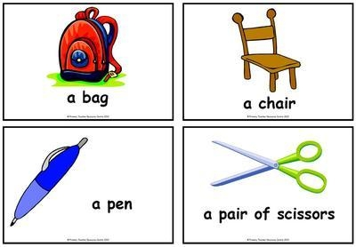

$79
$67

$32
$43

- ¿Cuánto cuesta la silla? _______________________________________________________
- ¿Cuánto cuesta el bolígrafo? ___________________________________________________
- ¿Cuánto cuestan las tijeras? ___________________________________________________
- ¿Cuánto cuesta la mochila? _____________________________________________________
Part II: Your teacher is shopping for the next school year. Translate her shopping list to Spanish. Spell out all numbers.

- 58 markers_________________________________________
- 84 pencils __________________________________________
- 100 notebooks _______________________________________
- 23 student desks_____________________________________
- 95 pencil erasers _____________________________________
- 103 papers __________________________________________
15 rulers____________________________________________

