El Proyecto de la Familia Nombre____________________
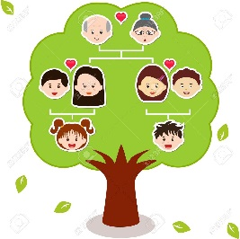
Project due on: ________________________
- Draw or find a picture of a tree at least as large as a piece of printer paper. Be creative!
- Use lines to connect your family members showing how they are related to you.
- Include the following on your tree:

- 6 or more family members, including yourself, with color drawings or photos of each.
- Use the following sentences as a guide to describe yourself.
Yo soy name.
Yo tengo # años.
- Use the following sentences as a guide to describe your family members.
Mi Spanish family vocab se llama name .
Tiene # años.
- Spell all vocabulary accurately and when writing out ages.

- Use your best penmanship and create a neat and visually appealing project.

El Proyecto-Page 2
Rúbrico del Proyecto
excelente bien más o menos no incluyó
Student included drawings/pictures of at least 6 family
members including themselves. 5 4 3 2 1

Student accurately wrote a sentence explaining each
person’s relationship to him/her and his/her names. 5 4 3 2 1

Student accurately wrote a sentence describing each
person’s age, spelling all numbers in Spanish. 5 4 3 2 1

Student described him/herself and wrote accurate
sentences about their name and age in Spanish. 5 4 3 2 1

Spelling and grammar in Spanish is accurate. 5 4 3 2 1

Student’s work is neatly done and easy to read. 5 4 3 2 1
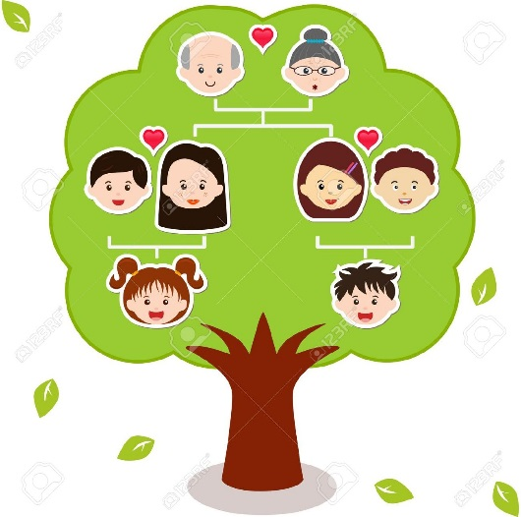
TOTAL: /30
PORCENTAJE: %

