Nombre:________________________________
Práctica II: Answer the questions below in complete sentences based on the information on the map.
¡RECUERDA!
? TÚ/USTED ______
? VOSOTROS/USTEDES ______________
? ALL OTHER FORMS __________________

- ¿De dónde eres tú?
_____________________________
- ¿Quién es de Perú?
_____________________________
- Pedro es de________________.

Él es ____________________.

- ¿De dónde son ustedes?
_____________________________
- Mariana es de _______________.

Ellas es ____________________.

- ¿Quiénes son de Paraguay?
_____________________________
- ¿De dónde es Carlota?
_____________________________
- Pepe y Ana son de ____________.

Ellos son ___________________.

- ¿De dónde somos Raquel y yo?
_____________________________

- Tú eres de _________________.
Tu eres ______________________.

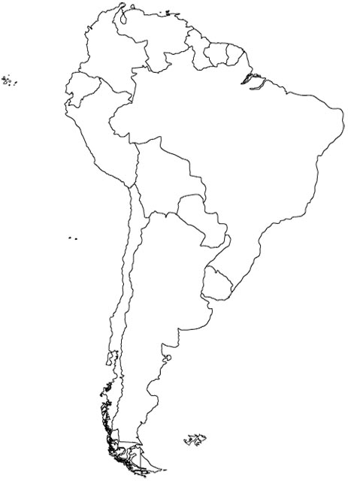
Carlota
Mariana
Pedro
Las muchachas
Raquel y yo
Anita
Ustedes
Pepe y Ana
Tú

