Nombre:____________________________________________
Práctica III: Review Sheet
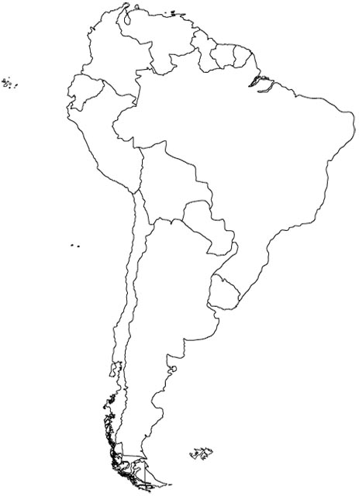
Part I: Write in the countries and their capitals below:
País (country) Capital
1
    - _____________________ ___________________
3
2
    - _____________________ ___________________
4
    - _____________________ ___________________
5
    - _____________________ ___________________
6
    - _____________________ ___________________
9
    - _____________________ ___________________
8
7
    - _____________________ ___________________
    - _____________________ ___________________
? TÚ/USTED ______
? VOSOTROS/USTEDES ______________
? ALL OTHER FORMS __________________

    - _____________________ ___________________
Part II: Answer in español. Use the information in parenthesis in your answer.
  - ¿De dónde eres tú? (Colombia)____________________________________________
  - ¿De dónde son ustedes? (Bolivia)__________________________________________
  - ¿De dónde sois? (Ecuador)_______________________________________________
  - ¿De dónde es usted? (Paraguay) __________________________________________
Part III: Traduce en español.
- We are from Uruguay. ________________________________________________
- They are not Peruvian._________________________________________________
- You all (informal) are Venezuelan._________________________________________
- I am not from Argentina._______________________________________________
- You all (formal) are Chilean.______________________________________________

