Student Resource Page III- Geography Clue: América Sur Nombre:_______________________
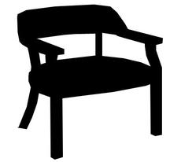
América Sur
Antonio

Write the countries of South America in their geographical order on the lines to the left.
The first letter of each of the words in the silly clue will help you remember their order on the map!
Very ____________________
Crafty ____________________
Elves _____________________
Put ______________________
Blueberry__________________
Pancakes ___________________
Under_____________________
Antonio’s ___________________
Chair ______________________

