El Proyecto- el presente Nombre:______________________________
Escribiendo un libro para niños
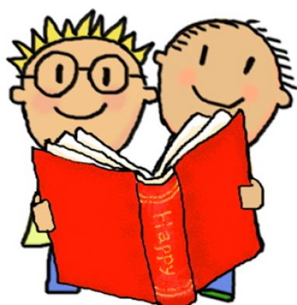
Writing a children’s book
FECHAS DE ENTREGA (dates of turn-in)
El borrador (rough draft):
______________________
El libro final (final book w/pictures):
______________________
Instrucciones: Write a ten page, ten sentence children’s book in Spanish. The book should be about an animal. Each page should have one sentence of the story and a colored drawing/picture/illustration of what is happening. The final book should be stapled in book format.
WARNINGS/RULES
- Focus on using words you know. You may use your –AR, -ER, and -IR verb lists for Spanish for verbs to include in the action of your story.
- Write in the PRESENT TENSE only!
- If necessary, you may look up words you don’t know IN A SPANISH/ENGLISH DICTIONARY or talk to me… YOU MAY NOT USE AN ONLINE TRANSLATOR OR A FRIEND FOR HELP!! If you are found to have used a translator instead of a dictionary, you will receive NO CREDIT for the assignment, and it must be redone!
- The rough draft does not need to be typed OR have pictures.
- The final draft must be in book form (stapled like a book) and have a picture/an illustration on each page. It may be handwritten OR typed.

REMEMBER TO … (El Proyecto-Page 2)
- Make the sentences simple. It is a book for children and a book written by you, someone who is a beginning Spanish student.
- Remember that we have talked about many places in the community. Remember the difference between ser and estar and their uses for describing people and emotions. You may also remember food words, clothes, colors, etc.
- Use correct spelling and accent marks. To get accent marks on the computer, you can go to Insert Symbol on Microsoft Word. I will also accept accent marks and tildes (~) written by you in black pen on the actual document. Accent marks MUST be included for full credit!
- Remember to connect sentences and say what you want to say. For example: a + el = al, also, de + el = del
Ejemplo (example) of 10 sentence/10 page story without illustrations:
p.1: Víctor es una vaca.
p.2: Víctor vive en una granja.
p.3: Víctor come (comer: to eat) pasto (grass).
p.4: Un día, Víctor rompe (romper: to break) la cerca (the fence) y camina a la ciudad.
p.5: Víctor la Vaca camina a la biblioteca.
p.6: Víctor busca (buscar: to look for) un libro sobre (about) vacas.
p.7: Víctor camina al restaurante.
p.8: Víctor come (comer: to eat) pizza y bebe (beber: to drink) leche (milk).
p.9: Víctor está cansado y feliz.
p.10: Víctor camina a la granja.
*Notice the verbs I used from the verb sheets to supplement the verbs we already knew. They conjugate like the rules we learned for conjugating –AR, -ER, and –IR verbs).
*Notice the number of words that we hadn’t learned. There are only a few! See?! You can do this!

