Práctica III: Direcciones

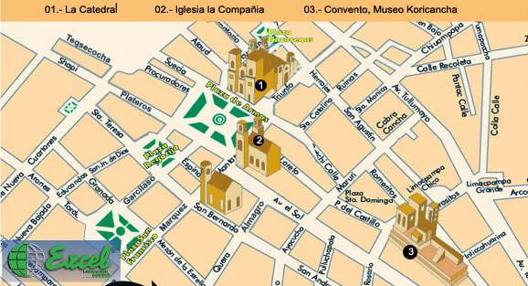
Use the map of Cusco, Perú to write step-by-step directions to visit the famous churches in Cusco. Begin at the the star (la estrella) and direct a traveler to the churches listed below.
Cusco,
Perú

- La estrella el Convento, Museo Koricancha

______________________________________________________________________________________________________________________________________________________
- La estrella La Catedral
_________________________________________________________________________________________________________________________________________________________________________________________________________________________________
el Convento, Museo Koricancha
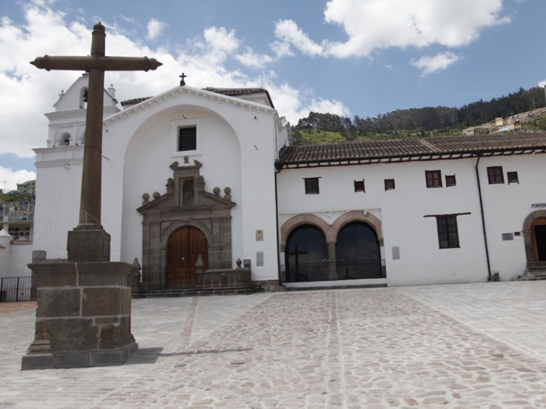
la Iglesia Compañía

La Catedral
