Práctica III: Todos los Reflexivos
Complete the sentences below by using the picture and time provided. Be sure to conjugate your verbs and write the times in Spanish. Use the clock notes to help if needed.
LA HORA
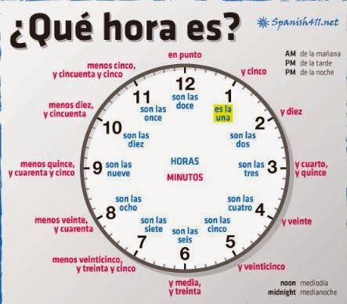
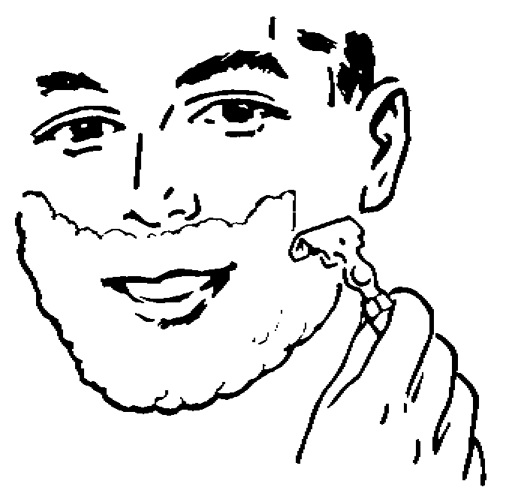
Modelo:
Alberto se afeita a las tres menos cuarto.
2:45

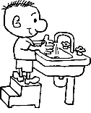
1.
Yo ___________________________________.
___________________________________
6:00
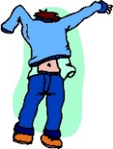
2.
Tú _______________________________________________________________________.
4:30

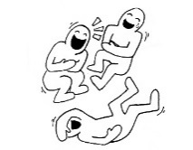
3.
Vosotros________________________________________________________________.
10:15
4.
Ustedes ________________________________________________________________.
1:20
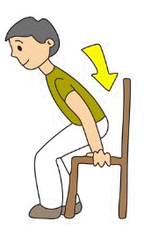
5.
Nosotros __________________________________________________________________.
6:50

