Práctica I: ¿Dónde está…? Nombre______________________________

Label the countries of Central America and the Caribbean. Make sure to spell the countries in Spanish!
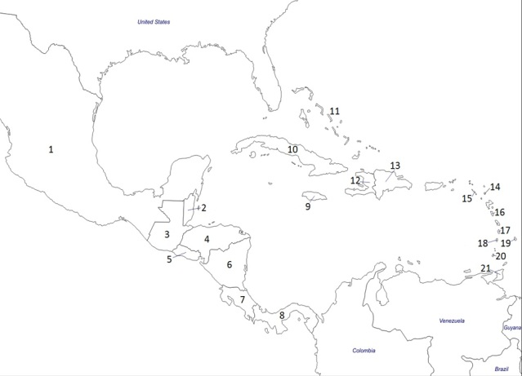

11

12

    - ____________________________ 10._______________________________
    - ____________________________ 11. _______________________________
    - ____________________________ 12. _______________________________
    - ____________________________ 13. _______________________________
    - ____________________________
    - ____________________________
    - ____________________________
    - ____________________________
    - ____________________________

