Práctica II: ¿Dónde está…?- Mexico and Central America
Write the capitals AND countries on the map below. Use Spanish spellings!
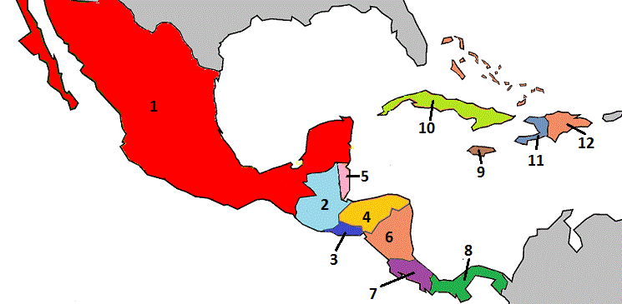
9

10

5

Country Capital
- ________________________ _______________________
- ________________________ _______________________
- ________________________ _______________________
- ________________________ _______________________
- ________________________ _______________________
- ________________________ _______________________
- ________________________ _______________________
- ________________________ _______________________
- ________________________ _______________________
- ________________________ _______________________

