E. Central America/Caribbean I: Geography and Nationalities ¿De dónde eres?: Student Resource Page I
Listen to your maestro/a and fill in the English equivalent of each vocabulary word below.
¿Dónde está ______? | Where is _______? | Belice  beliceño/a | Belize  Belizean
¿De dónde eres (tú)? | Where are you (inf) from? | los Estados Unidos (E.E.U.U.)  estadounidense OR americano/a | United States (USA)  American
¿De dónde es usted? | Where are you (f) from? | Costa Rica costarriqueño/a | Costa Rica  Costa Rican
¿De dónde es él/ella? | Where is he/she from? | Puerto Rico  puertorriqueño/a | Puerto Rico  Puerto Rican
(Yo) soy de _____. | I am from _____. | Guatemala  guatemalteco/a | Guatemala  Guatemalan
(Yo) soy ________. | I am (nationality). | Nicaragua  nicaragüense | Nicaragua  Nicaraguan
México  mexicano/a | Mexico  Mexican | Cuba  cubano/a | Cuba  Cuban
Panamá  panameño/a | Panama  Panamanian | El Salvador  salvadoreño/a | El Salvador  Salvadorean
Honduras  hondureño/a | Honduras  Honduran | la República Dominicana dominicano/a | Dominican Republic  Dominican
Use this chant to help you remember the order of the countries in Central America. Use your Central American map practice sheets to help you. Practice saying the countries and touching the correct spot on the map to lock it into your brain.
América Central
¡Buenos días a Belice!
Going to Guatemala!
¡Saludos a El Salvador!
¡Viva, viva, viva Honduras!
¡Viva, viva, viva Nicaragua!
¡Viva, viva, viva Costa Rica!
¡Viva, viva, viva Panamá!

¿De dónde eres?: Student Resource Page II Nombre:______________________

Use the map below as a reference for this unit.
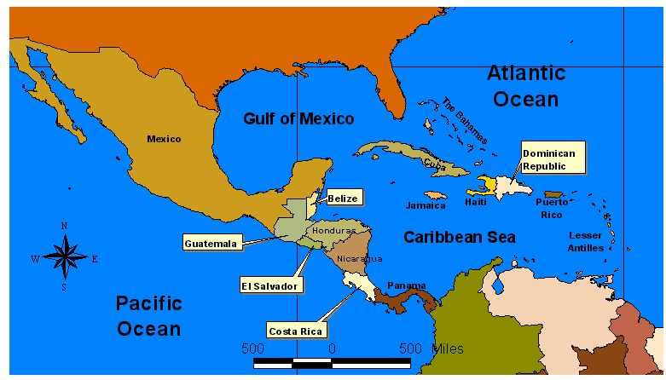
La República
Dominicana
Puerto Rico
Cuba
Panamá
Belice
México
Los Estados Unidos
Capitales:
México – México D.F.
Guatemala- Guatemala
El Salvador- San Salvador
Honduras- Tegucigalpa
Nicaragua- Managua
Costa Rica- San José
Panamá- Panamá
Cuba- La Habana
La República Dominicana- Santo Domingo
Puerto Rico- San Juan
Student Resource Page- Geography:América Central Nombre___________________________________

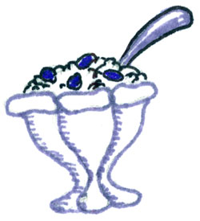
América Central

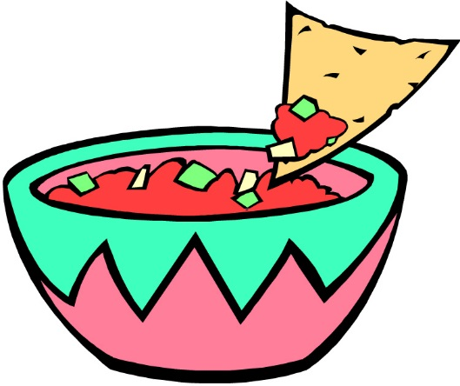

My __________________________
Write the countries of Central America in their geographical order on the lines to the left.
The first letter of each of the words in the silly clue will help you remember their order on the map!
Big__________________________
Gentle __________________________
Hippo__________________________
Eats Salsa __________ ________________________
Not __________________________
Chunky Rice ___________________ __________________
Pudding __________________________

Student Resource Page- Geography: El Caribe Nombre_________________________________

el Caribe
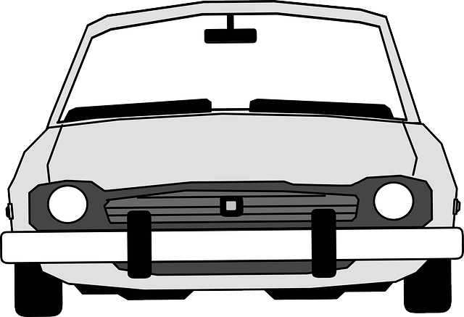
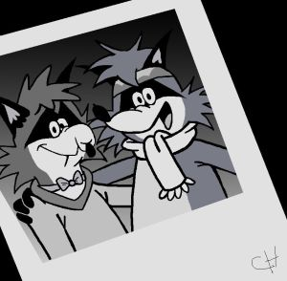

Write the countries of the Caribbean in their geographical order on the lines to the left.
The first letter of each of the words in the silly clue will help you remember their order on the map!

Crazy ______________
Raccoons Drive (la)_____________ ______________
Past Rudolph _______________ ______________

