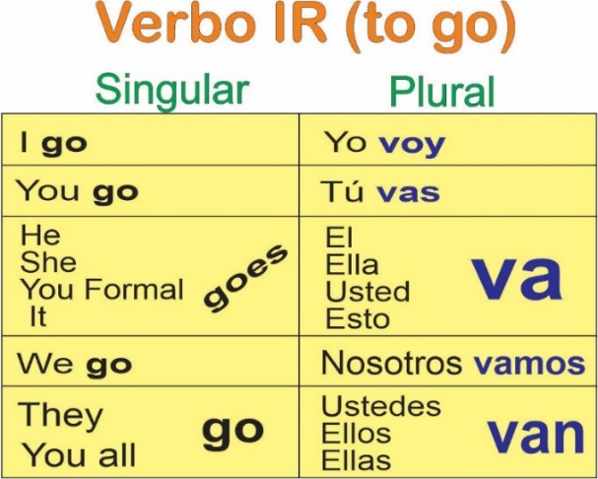
- Verbo “ir” + a – The Verb “ir” + a:
A simple way to speak about destinations and the future

- Yo voy al cine I go to the movie theater
- Ella va a la playa She goes to the beach
- Nosotros vamos a la iglesia We go to the church

TIP: Using the VOY conjugation to talk about the future

The formula for future: Noun + VOY A + infinitive verb (ar, er, ir)
Yo + VOY A + dormir
Tú + VAS A + caminar

Example Verb IR (To go)
Present: Yo voy a la escuela Tú vas a trabajar ahora
Future: Yo voy a ir a la escuela Tú vas a ir a trabajar el lunes
el próximo año

Example Verb SER (To be)
Present: Yo soy doctora Tú eres Ingeniero
Future: Yo voy a ser doctora Tú vas a ser Ingeniero en unos años terminando tus estudios.

Example Verb ESTAR (to be)
Present: Yo estoy en Minnesota Tú estás en la casa
Future: Yo voy a estar en Mn Tú vas a estar en la casa
la próxima semana en media hora.

Example Verb TENER (To have)
Present: Yo tengo un coche Tú tienes una casa
Future: Yo voy a tener un coche Tú vas a vas a tener una casa en unos años

Exercise: Say the present and future tense and find out which verb to use.

Ej. Yo/ escuela---- Yo estoy en la escuela----Yo voy a estar en la escuela mañana

- Él / campo
- Ella / Universidad
- Nosotros / caballo
- Ellos / algunos animales
- Usted / Arquitecto
- Ellos / a la playa
- Yo / un coche

- Answer the next questions:
- ¿A dónde vas mañana?
- ¿Qué vas a estudiar?
- ¿Qué vas a hacer hoy?
- ¿Qué planes tienes para el próximo año?
- ¿Qué tienes que hacer para el fin de semana?

- Los Adverbios – Adverbs:

What Is an Adverb?
By definition, adverbs are invariable words that modify verbs, adjectives and other adverbs. This is very important to remember since adverbs never modify nouns (you cannot say rápidamente libro — quickly book, but you can say levantarse rápidamente — to get up quickly).
There are different groups of adverbs and each of them answers different specific questions.

TIPOS DE ADVERBIOS/ TYPES OF ADVERBS
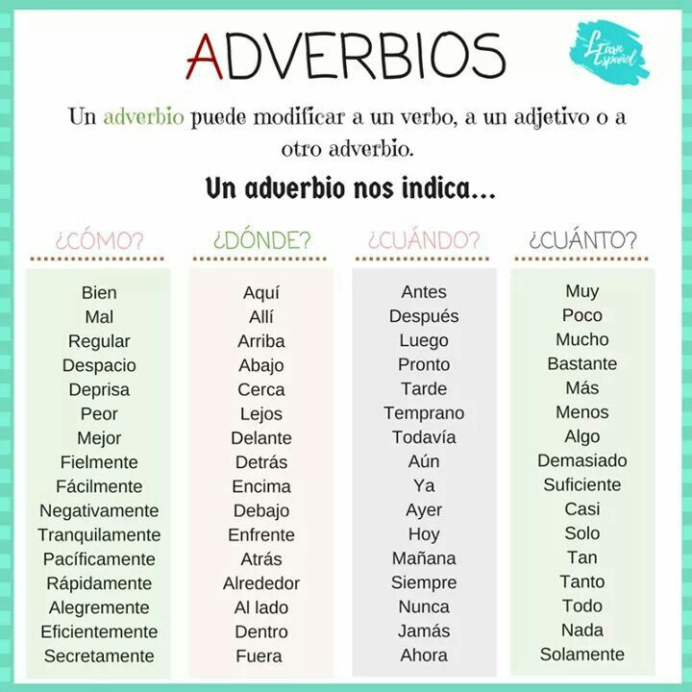

- Los Adverbios – Adverbs: Types Of Adverbs

Lugar – Place
aquí, acá | here
ahí,allí,allá | there
allá | over there
encima | above/over
arriba | up/above
debajo | underneath
abajo | below, down
cerca | close
lejos | far
delante | in front
detrás | behind
a lado | next to/beside
Tiempo – Time
ahora | now
anteayer | day before yesterday
ayer | yesterday
hoy | today
mañana | tomorrow
luego | later
después | after
antes | before
temprano | early
pronto | son
tarde | late
todavía | yet
aun | still
mientras | while
ya | already
siempre | allways
nunca | never

Orden – Order
antes | before
después | after
sucesivamente | successively
primeramente | firstly
últimamente | lastly
finalmente | finally
siguiente | next
respectivamente | respectively

Modo - Manner
bien | fine/good
mal | bad
mejor | better
peor | worse
así | so
despacio | slow
rápidamente | quickly
fácilmente | easily
naturalmente | naturally
Cantidad – Quanitity
bastante | quite/fairly
mucho | a lot
muy | very
más | more
demasiado | too much
nada | nothing
poco | little/short
tan/tanto | so
menos | les
apenas | barely

Negación – Denial
no | no
tampoco | either
nunca | ever
jamás | never
ni | nor/ or

Afirmación – Affirmation
si | yes
claro | sure
cierto | true
seguro | for sure
por cierto | by the way
sin duda | without a doubt
ciertamente | certainly
efectivamente | effectively
seguramente | indeed/surely
por supuesto | of course

Duda – Doubt
tal vez | maybe
quizá | maybe
acaso | perhaps
probablemente | probably
posible | possible

- 4. Los Adverbios – Adverbs: How to form them in Spanish
Every Spanish word that ends in -mente is an adverb, equivalent to -ly in English.
MENTE
Adjective in
FEMENINE

Put any adjective in feminine form and add the MENTE ending as follow:
lento | slow | lentamente | slowly
silencioso | silent | silenciosamente | quietly
misterioso | mysterious | misteriosamente | mysteriously
violento | violent | violentamente | violently
*If there is no feminine form, still we add the mente ending
fuerte | strong | fuertemente | strongly
valiente | brave | valientemente | bravely
inteligente | smart | inteligentemente | smartly

5. Los Adverbios – Adverbs: Placement
The placement of Spanish adverbs can be difficult. Whereas in English their placement is sometimes arbitrary (they might be found before or after the verb, or even at the beginning or end of the sentence), the placement rules for Spanish adverbs are much stricter.
1.When a Spanish adverb is modifying a verb, it is placed after the verb.
Comimos bien esta mañana……… ……We ate well this morning
Los libros llegaron afortunadamente…… The books arrived, fortunately

Practice: Try to say the next sentence:
- We slept (dormimos) bad last night
- We ate (comimos) delicious!
- You work a lot!
- She walks slowly!
- They wake up late

2.An adverb cannot be placed in between two verbs or between an auxiliary verb and main verb; it is placed after both of them.

Vamos a comer bien……………We’re going to eat well

Has aprendido rápidamente…. You have learned quickly OR
You have quickly learned.
Practice: Try to say the next sentence:
- We will drive (manejar) slowly………………
- He will go to exercise (hacer ejercicio) hard
- She learns (aprender) fast
- She walks (caminar) and breath (respirar) slowly!
- I like to sleep (dormir) deeply

3. When an adverb is modifying an adjective or another adverb, it is placed in front of the word it is modifying.
Comimos muy bien. |  | We ate very well.
Sus ideas son completamente locas. |  | His ideas are completely crazy.

Practice: Try to say the next sentence:
- We arrived very late
- They are very young
- The gas is too expensive
- Traveling is so much fun
- Your dress is completely dirty
There are more rules to the placement and uses of Spanish adverbs, but these three apply to the majority of situations.

