1. Review of Preterite tense conjugation
The preterite tense is used to express finished or complete actions that happened in the past.
Trabajé en la oficina ayer. (I worked in the office yesterday.)
It can also indicate an action occurring in the present that began at a specific point in the past:
Empecé a estudiar ayer. (I began to study yesterday.)
Conjugation –AR (ER/IR) verbs en el Pretérito
Step 1: Drop the –AR (ER/IR) ending to leave the stem of the verb.
IE: Hablar Hablar habl__
Step 2: Add the new conjugated ending depending upon the pronoun.
IE: Hablé Hablaste Habló etc.
Note: For regular verbs, the ‘yo’ and ‘él/ella/usted’ pronouns have an accent on the last vowel.

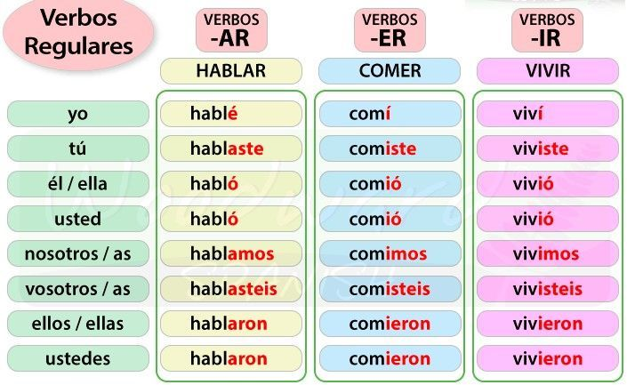

2. Práctica- Practice: Translate the sentences using el pretérito.
- 1. She won.
- 2. They cleaned.
- 3. We hugged.
- 4. I returned.
- 5. You all (inf.) sang.
- 6. You (f.) explained.
- 7. He learned a lot.
- 8. They didn’t understand the lesson.
- 9. Ana and I ran in the park last night.
- 10. We drank margaritas at the restaurant this weekend.

3. Break out Rooms- Conversation Practice: Using Preterite tense- Talking about what they did last night and on the weekend.
Anoche, ¿Usaste la computadora? ¿Viste la televisión? ¿Comiste en la casa o en un restaurante? ¿Qué hiciste anoche?
Fin de semana pasada, ¿Viste una película? (un partido de fútbol americano?) etc.
¿Cocinaste algo nuevo? ¿Limpiaste la casa? ¿Trabajaste afuera?
¿Qué hiciste este fin de semana?

4. Más Práctica: More Practice: Make Spanish sentences using the information provided. Make sure to conjugate the verbs in the preterite tense.
- Yo/Bailar/last night
- Juan Carlos/correr/the day before yesterday
- Lupe y yo/escribir/last Wednesday
- Vosotros/limpiar/yesterday
- Usted/decider/last month
- Tú/viajar/last summer
- Yo/vivir en Colombia/seven years ago
- Tú y yo/comer las enchiladas/last week
- Ustedes/trabajar/last Sunday
- Las muchachas/comprender/four days ago

5. El Vocabulario – Vocabulary: Holiday & Festival Vocabulary
Common conversation starters for preterite:
- ¿Qué hiciste para la Navidad? What did you do for Christmas?
- ¿Qué comiste ayer para el día de accion de gracias? What did you eat at Thanksgiving?
- ¿Qué disfraz usaste para Halloween? What costume did you wear for Halloween? (Or la noche de brujas)
- ¿Celebraste el día de los muertos? Did you celebrate Day of the Dead?

los días feriados | the holidays
Feliz | Happy
El Día de los Muertos | Day of the Dead
El Día de Acción de Gracias | Thanksgiving
La Navidad | Christmas
El Año Nuevo | New Year’s Day
El Día de San Valentín | Valentine’s Day
La Pascua, La Semana Santa | Easter, Holy Week
Día de la Independencia | Independence Day
el disfraz | the costume
el desfile | the parade
celebrar; las celebraciones | to celebrate; the celebrations

(Scroll to next page for Irregular verb lesson)
6. Preterite Part 2 Lesson- Irregular Past Tense Conjugations: Hay muchos verbos irregulares en el pretérito. There are many irregular verbs in the preterite tense. Today we will cover some common ones and discuss stem changes in preterite as well as some spelling changes. Next class we will continue with irregulars and start learning about the other past tense- the imperfect tense.
Los verbos SER e IR tienen las mismas conjugaciones en el pretérito. The verbs SER (to be) and IR (to go) have the same conjugations in the preterite. These are commonly used verbs and do not follow the traditional steps for regular conjugation. Instead, the preterite tense stem is “fu”. Please view the conjugation chart below for the complete conjugations.
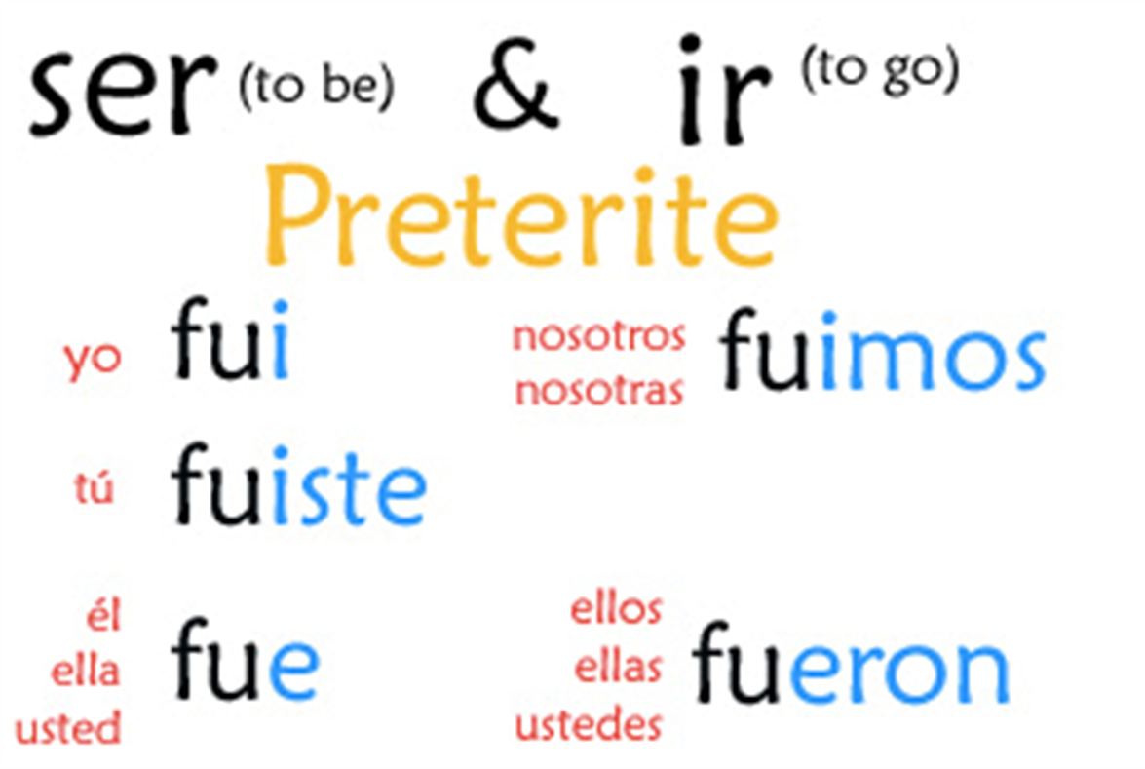

Some verbs have spelling changes in the preterite tense. Los verbos que terminan en -CAR, -GAR, y -ZAR, solo cambian en la forma de Yo. The verbs that end in -CAR, -GAR, and -ZAR, only change in the yo form. The reason for this change is that the Spanish spells the sounds /k/, /g/, /s/(spelled z) differently before e and i.
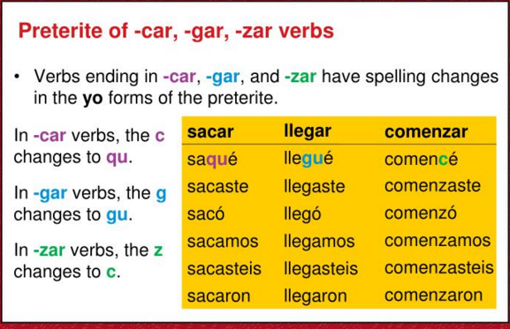
Verbs with Stem changes in the Preterit: Stem-changing -AR and -ER verbs do not have any stem changes in the preterit because the stem is not stressed in any of the forms. IE: Pensar and Volver
Yo pensé. (preterite tense) Vs Yo pienso. (present tense)
Yo volví. (preterite tense) Vs. Yo vuelvo. (present tense)
However, -IR verbs having a stem change in the present tense DO have stem changes in two forms of the preterit tense- the él/ella/Usted form (third person singular) and the ellos/ellas/Ustedes form (third person plural). IE: The verb dormir (to sleep) change o to u in these forms.
dormí | dormimos
dormiste | dormisteis
durmió | durmieron

Verbs having the stem changes e> e or e> ie in the present change e to I in the same forms as above.
IE: Sentir (to feel) Present tense stem change is e to ie. Yo siento.
sentí | sentimos
sentiste | sentisteis
sintió | sintieron

IE: Pedir (to order) Present tense stem change is e to i. Yo pido.
pedí | pedimos
pediste | pedisteis
pidió | pidieron

Spelling changes in -ER and -IR verbs whose stems end in a vowel. These verbs change the i in the third- person preterit endings to -ió and -ieron to y. This is not just a spelling convention. The y is actually pronounced in these forms. All of the remaining persons have a written accent on the i of the preterit ending, not just the yo form.
Leer- to read
leí | leímos
leíste | leíste
leyó | leyeron

Practice- Work together as a class to conjugate the verb oír (to hear) in the preterite tense using this grammar rule from above.

*If time, Optional Culture lesson: Día de los Muertos
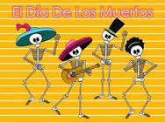
The Mexican holiday of Día de los Muertos, or Day of the Dead, takes place over the first two days of November. Its origins are a mixture of native traditions and the Catholic faith. While the holiday’s observances include spending time in cemeteries, making shrines for the dead, and displaying artistic representations of skulls and skeletons, the occasion is festive, rather than scary or morbid. Death isn’t seen as the end of one’s life, but as a natural part of the life cycle. It is believed that the dead continue to exist much as they did in their lives and come back to visit the living every year.
It is generally believed that the souls of one’s family return home to join in the Day of the Dead festivities. Families set up altars (ofrendas) in their homes, festively decorated in bright colors and filled with the favorite foods of their dead. Typically, the altars contain photographs of the dead, representations of things they liked, and items representing four elements: candles for fire, drinks for water, fruit for earth, and fluttering tissue-paper decorations for wind.
The major feature of Day of the Dead decorations is skeletons, or calacas. Skeletons are everywhere, from tissue-paper scenes to tiny plastic toys. These skeletons are usually cheerful. Also common are skulls and skeletons made of sugar or candy.
While Day of the Dead and Halloween both stem from All Saints’ and All Souls’ Days, their tones couldn’t be more different. Halloween’s images of skeletons and spirits emphasize the spooky and scary elements. On the Day of the Dead, however, the focus isn’t scary at all. It’s about celebrating with one’s family, alive and dead, and remembering those who are no longer alive. (pictures below)
