1. Infinitive verbs:
In Spanish, infinitives always end in -ar, -er or -ir. In English, "infinitive" is usually used to refer to the "to + verb" form of the verb such as "to run" or "to eat. Examples:
English infinitive | Spanish infinitive
to hug | abrazar
to eat | comer
to open | abrir

2. Infinitive verb vs conjugated verb:
Infinitive verb | Subject pronoun | Conjugated verb
comprar (to buy) | yo | yo compro
correr (to run) | tú | tu corres
estudiar (to study) | él, ella, usted | el, ella, Ud, estudia
creer (to believe) | nosotros | nosotros creemos
preguntar (to ask) | ustedes | ustedes preguntan
llamar (to call) | ellos | ellos llaman

3. Conjugation AR, ER, IR verbs:

Step 1: Find the infinitive Comprar
Step 2: Drop the ‘AR’ to leave the STEM comprar compr
Step 3: Add the new ending Yo compro
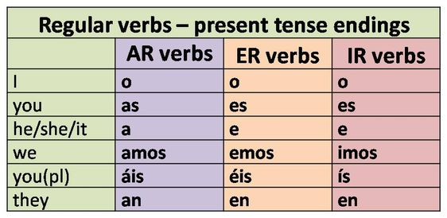

Regular verbs have the same stem and when conjugated the stem keeps the same only the endings change.

AR ER IR

amar | to love |  | comer | to eat |  | vivir | to live
comprar | to buy |  | crecer | to grow |  | escribir | to write
estudiar | to study |  | aprender | to learn |  | subir | to go up/climb
caminar | to walk |  | cojer | to grab |  | abrir | to open
necesitar | to need |  | correr | to run |  | asistir | to attend
viajar | to travel |  | deber | to owe |  | exigir | to demand
buscar | to look for |  | temer | to fear |  | existir | to exist
pensar | to think |  | escoger | to choose |  | aplaudir | to clap
llevar | to carry/take/wear |  | aprender | to learn |  | asistir | to attend
abrazar | to hug |  | vender | to sale |  | permitir | to allow

Conversation and practice: Translate in spanish with the correct conjugations.
Example:
What are you taking (llevar) to the party? ¿Que llevas a la fiesta?
- What do you (formal) cook (cocinas)?
- ¿What do they eat (comer)?
- How do you learn (aprender) Spanish?
- At what time does she leaves (salir) ?
- What do they need (necesitar)?
- Where do they study (estudiar)?
- We dance (bailar) every weekend.
Example COMPRAR Example PODER

Yo O | Nosotros amos
Tu as | Vosotros áis
É  Ella a  Usted | Ustedes  Ellos an  ellas
Yo O | Nosotros emos
Tu es | Vosotros éis
Él  Ella e  Usted | Ustedes  Ellos en  ellas

Example MENTIR
Yo O | Nosotros imos
Tu es | Vosotros ís
ÉL  Ella e  Usted | Ustedes  Ellos en  ellas

abrazar | to hug | explicar | to explain | aprender | to learn
ayudar | to help | ganar | to win | beber | to drink
bailar | to dance | gastar | to spend | comer | to eat
besar | to kiss | hablar | to talk/speak | comprender | to understand
buscar | to look for | limpiar | to clean | correr | to run
cambiar | to change | llamar | to call | creer | to believe
cantar | to sing | llegar | to arrive | leer | to read
comprar | to buy | llevar | to wear | aprender | to learn
contestar | to answer | mirar | to watch/look at | abrir | to open
descansar | to rest | nadar | to swim | decidir | to decide
dibujar | to draw | preguntar | to ask | discutir | to discuss
enviar | to send | regresar | to return | escribir | to write
escuchar | to listen | trabajar | to work | recibir | to receive
esperar | to wait for | viajar | to travel | subir | to climb/go up
estudiar | to study | visitar | to visit | vivir | to live

Translate to Spanish with the correct conjugation.
- I travel 8. You (formal) sing
- We eat 9. He works
- They arrive 10. They (M) drink
- He writes 11. I understand
- I wait 12. They (F) visit
- They return 13. We work

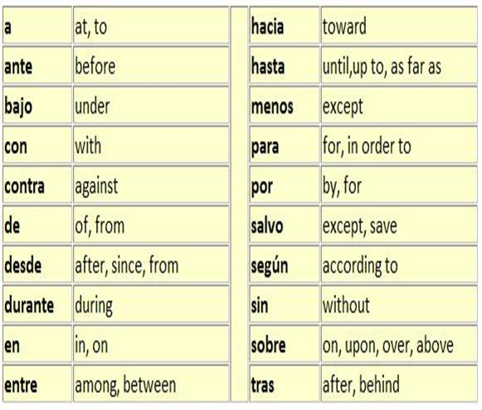
4. Useful Prepositions:
Preposition Uses:
1) Preposition + noun:
Contra mi auto / against my car
Sin dinero / without money
2) Preposition + pronoun:
Para mí / for me
Entre nosotros / among us
3) Preposition + infinitive:
Sin comer / without eating
4) Verb + Preposition:
Viniendo de lejos / coming from far away
Voy hacia la locura / I am going crazy

How to use prepositions in Spanish
Prepositions in Spanish are pretty easy to understand as they often function in almost the same way as they do in English language. Here are some examples on how to use them in a sentence

1.English: I (subject) am going (verb) to (preposition) the store (prepositional object).
Spanish: Yo (subject) voy (verb) a (preposition) la tienda (prepositional object).

2. Atlanta es la capital de Georgia.
Atlanta is the capital of Georgia.

3. Ella es de Uruguay.
She is from Uruguay.

4. Está en mi mochila.
It is in my backpack.

5. Trabajo con los estudiantes
I work with the students

6. Viví en México hasta el quinto grado
I have been living in Mexico until fifth grade

Practice: Translate to Spanish:

- The good ones are fighting(peleando) against the bad ones.
- I don’t go out without my phone.
- This present (regalo) is for you
- I don’t eat meat during the lent
- The store is between those two houses

