**Vamos al Parque**

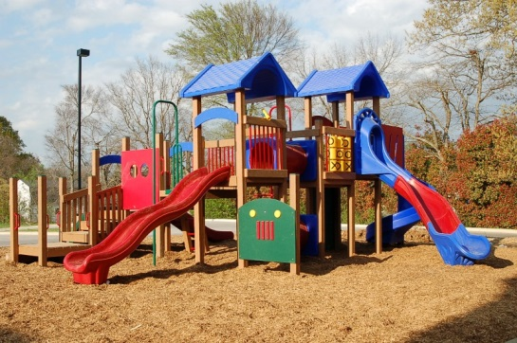Today we had fun learning vocabulary and conversation in Spanish that can be used at “el parque” (the park). If possible take your child to the park and practice the vocabulary from the newsletter with repetition. For example if you see the see saw you can play on the see saw saying the word in Spanish “subibaja.”

**Directions:** Draw your own amazing park below using the vocabulary from Spanish class below!

**Word bank:** *el parque, el bebedero, la resbaladilla, el subibaja, los columpios, amigo*

**Practice:** Use the new phrase from class today “Hay” to show what fun activities are in your park. You can show your picture to a friend or family member describing it with this phrase in Spanish. For an extra challenge you can practice writing the full sentences with the word bank above to label the picture in full sentences with the phrase “Hay.” For example: *Hay los columpios.* There are swings.

C:\Program Files (x86)\Microsoft Office\MEDIA\CAGCAT10\j0158007.wmf