Easy Plantain Recipe-Courtesy of Chiquita
Prep Time:10 minutes
Total Time:20 minutes
Cook Time: 5-10 minutes
Serves: 4
Plantains or plátanos are very popular in Puerto Rico. Your child learned about Puerto Rico in class today. To take the culture home, try cooking up some plantains together! They are great topped with avocado, shredded chicken, pico de gallo, or just even with a good dash of salt.
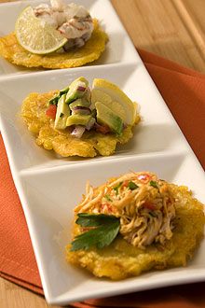
Tip: You can find plantains in the Latin American section at your large supermarkets or at specialty grocery stores, like Mexican ones.
For extra culture: Type in Puerto Rico or Salsa into Pandora and play the music in Spanish while you cook.

Ingredients:
- 2 whole Green Chiquita Plantains
- 2 cups Vegetable Oil

Instructions for Plantains Recipe:
Pour about 2 inches of oil in small, deep pot and turn burner on medium high. Slice Chiquita Plantains in 1 1/2 inch sections (you should get about 6 pieces per plantain). Place cut-side-up on a solid surface. Carefully press down and flatten the Chiquita Plantain with the bottom of the frying pan or other flat surface (like bottom of a drinking glass). Once oil is hot, cook for about one minute. Cook in hot oil for two minutes or until they turn golden. Place on paper towel to absorb any extra oil. Serve with your choice of toppings.

