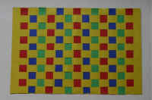Mayan Weaving

Guatemalans are famous for their beautiful weaving techniques. Huipiles are the beautiful blouses. It takes many months to finish one product. To get an idea of what weaving is, you are going to make a simple woven placemat using bright colors. Then have a pretend market to sell your placemat!

You will need:
Scissors Glue or tape (Several) Completed example
Pencil Ruler
16 strips of construction paper 1” wide by 12” long
18x12” piece of construction paper

To Do:
- Fold the large piece of construction paper in half across the width.
- Page: 2
Use your ruler to mark 1” intervals along the folded edge of the paper
- Page: 2
Repeat on the open edge, but make the marks 1” from the edge of the paper
- Draw a line connecting the marks.
- With the paper still folded and starting at the fold, cut along the lines. Stop one inch from the open edge.
- Unfold the paper to reveal the loom that you have created.
- Weave the strips through the loom. If you are using multiple colors, alternate them for the most colorful effect.
- Glue the ends of the strips to the edges of the loom to hold them in place.
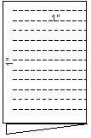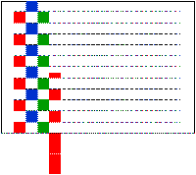
Notes: For younger students, have the paper strips already cut. For all classes, you can start the project and ensure that students know how to do it. However, you can send home incomplete work to finish at home if time is constrained

