Vamos a Acampar Abbreviated Lesson Plan: Day 3
Day 3 Target Vocabulary: Vamos a nadar *Use physical gestures when teaching these more challenging vocabulary words for the students to mimic and physically connect to the lessons.
Vamos a nadar | Let’s go swimming | Tengo calor | I’m hot
el traje de baño | swimsuit | las toallas | towels
el lago | lake | la protección del sol | sunscreen
los anteojos del sol | sunglasses | el tubo inflable | inner tube
jugar en el agua | play in the water | la pelota (inflable) | beach ball
saltar del muelle | jump off the dock

Builder phrases to emphasis: Tengo____; Necesito____; Necesitamos ________

Materials needed: Flashcards (2 sets from this week and one set from weeks 1 and 2) with the target vocabulary; As many real props as possible! For example, a blue blanket or large blue towel to represent the ‘lago’, sunglasses, bathing suit, inner tube if possible and a ball. Have these items set up before the students enter the class. Also, bring items from Day 1 and Day 2 if possible. Puppets, an object to pass for conversational components, notas culturales intranet pictures of “Lago Avándaro” and Mexico City; and an ability to play music for the “Hielo” game.
You: Prepare the items and line them up in the order that you will do them. If you want to make it really fun, dress wearing your sun glasses with a towel around your neck for ‘swimming’!
Vobulary Instruction Methodology: TEACH the vocabulary; REINFORCE the vocabulary; CHECK IN for vocabulary retention.
I. Have Spanish music playing as the students enter the room.
II. Greet each child as they enter the room. ¡Hola! ¡Bienvenidos! Ask them their names in Spanish and mark it on the attendance document. Be sure to give each child their name tag at this time. (Follow up on attendance as needed) Ask them ¿Cómo te llamas? Encourage them to respond: Me llamo___ .
III. Have the class sit in a circle on the floor, and greet everyone with a lively ¡Buenas tardes clase! Introduce ¿Cómo estás? As well as Estoy bien o mal by using gestures of thumbs up or down and making corresponding faces. Have a maraca, a ball or similar to pass around the circle and have each child ask and answer the question. Then say ¡Buen trabajo! Nice to meet you! Check in and ask what ¿Cómo estás? means.
IV. Stand and sing your chosen greetings song using gestures.
V. Sit back down in the circle
VI. Review the rules by having the class participate in saying each rule.
VII. Remind everyone that they currently have three estrellas and that if they have all three estrellas by the end of class they can get a sticker or a peso. (*Be sure to have a system to save the pesos or track them. Also, it is a good idea to have a collective place for the students to collect stickers like a name tag, folder, or pre-designed certificate.)
IV. Bring out Dani and Beto and ask the students in Spanish if they remember their names. Encourage them to greet them with, “¡Hola Dani y Beto!”
V. Remind the students that Dani and Beto are camping (a acampar). Have the class say with you, “¡Vamos a acampar!”
VI. Theme song: Stand and sing the theme song with gestures*.
Vamos a Acampar (Sing to the tune of the Farmer in the Dell)
Vamos a Acampar
Vamos a Acampar
Con mis amigos, voy a acampar

VII. Review the past vocabulary from the first two weeks: Have the objects or flashcards from last week set around the room. Have the students march around the room with and point to each object, saying the name of it in Spanish. (Alternately, hold up the flashcards and have the students repeat the words after you for a very short review.) Then play a review game such as “Baile del Campamento’ o ‘Empacar la hielera’ to review the past two weeks’ key vocabulary. Don’t forget about reviewing the builder phrases to encourage conversation: Necesito and Tengo.
VIII. Teach the new vocabulary: Gather the students back into the circle. Pull out Dani and & Beto and lay out either the flashcards or the real items with the pretend ‘lago’.
Beto: Tengo calor. I am hot. (Have the class repeat and reinforce tengo)
Dani: Sí, have mucho calor y sol hoy. Yes, it is very hot and sunny today.
Beto: Debemos nadar en el lago. We should swim in the lake.
Dani: Buena idea, Beto! ¡Qué divertido! Great idea, Beto. How fun!
Beto: ¡Vamos a nadar! Let’s go swimming! (Cue the class by asking what ‘vamos’ means and have the class make swimming gestures)
Dani: Necesitamos preparar para ir al lago. We need to prepare to go to the lake.
IX. Reinforce the new vocabulary: This is a great lesson to make really come alive. Have the “lake” set out with the corresponding objects in it and around it in a different part of the room. Move to “el lago” and have the students sit down. Get the students excited by saying, “Bienvenidos al lago!” Teach the new vocabulary by holding up each prop and have each student repeat the words after you at least one time, preferably more. Speed it up as they start to remember to make it more fun.
IX. Check in to see if the kids know the vocab: Lay out the objects/flashcards. (You can include the items from last two weeks too.) Call out a vocab word in Spanish by saying the builder phrase Necesito + the object and have volunteers point to the corresponding object. Alternatively, you can hold up the objects/cards and have the students say the words when you ask ¿Qué necesitas? and they answer Necesito + the object. This is a very important step before moving to a game.

X. Juego-: El Lago game-You will need the picture flashcards of the new vocabulary, two sets if you have a larger class. Gather your students and explain that this is similar to the Cake Walk game. Place the flashcards around your ‘lago’ similar to stepping stones. First explain the directions that students will walk around the ‘stones’, picture to picture, while the music is played. When the music pauses, each student has to stand next to one of the words. Randomly call out a vocabulary word in Spanish. The student standing next to that word has to ‘levantar la mano’ and repeat it in Spanish. Then, cue the class to repeat, ‘clase repitan por favor ____’ for further reinforcement. *Tip: Play the game for 5-7 minutes. It’s ok if not all students have a turn; you can allow them a turn in the next game.

*Alternate activity for older students: Swimming challenge: You will need one set of flashcards (or live visuals) plus one set of cards with only the words, not the images. Have the pictures spread out around the room. For larger classes, divide into two teams. One team is given the word flashcards and has to race around the room placing the Spanish word flashcard next to the image. Whichever team completes it the fastest and does it correctly, earns a peso or sticker. *Variation: you could have the picture flashcards and the incorrect Spanish word flashcards mixed up and students have to move them around to correctly match them. Keep playing for 5-7 minutes or until every player has a turn and be sure students are repeating the words together as you go around to correct their matching.
XI. Reinforcement Activity: ¡Salta! This is a simple way to reinforce vocabulary. Choose three vocabulary words and put the flash cards in three columns in a part of the room where there is a lot of space. Have the students line up going across. Explain that when you call out a word the students must jump (saltar) to that vocabulary flashcard column. Example: “ ¡Toalla!” The students would jump towards that flashcard. Those who didn’t would be out of the game. Make it fun by speeding it up. This is a great way to ensure the kids really master these three words!
Alternate juego/reinforcement activity: Sigue el líder: Play a game of follow the leader around the room with the new action words. Have large pieces of paper with the vocabulary words individually placed around the room. Have the class follow you, the líder, to a station around the room to act out the posted vocab word that you pass. Make this fun: have everyone act out the word like “Tengo calor” one by one as they individually repeat the word. This is great practice. If you have an older child, invite him/her to be the ‘líder’ to continue the game.

XII. Merienda Y Notas Culturales: Have the students get their snacks and go sit at the table quietly while you teach the culture portion of today’s class. Remember this cultural part is not optional! If you have a laptop or tablet, show the week 3 cultural pictures from the intranet, or bring them printed off to pass around. If you can, bring in a map and ask the students if they know where Mexico is or if anyone has ever visited there. Talk about how Mexico City is the capital and third largest city in the world. The streets are crazy and they are crowded with buses, taxis and people walking. The city is very polluted and you can see some people walking around with face masks.
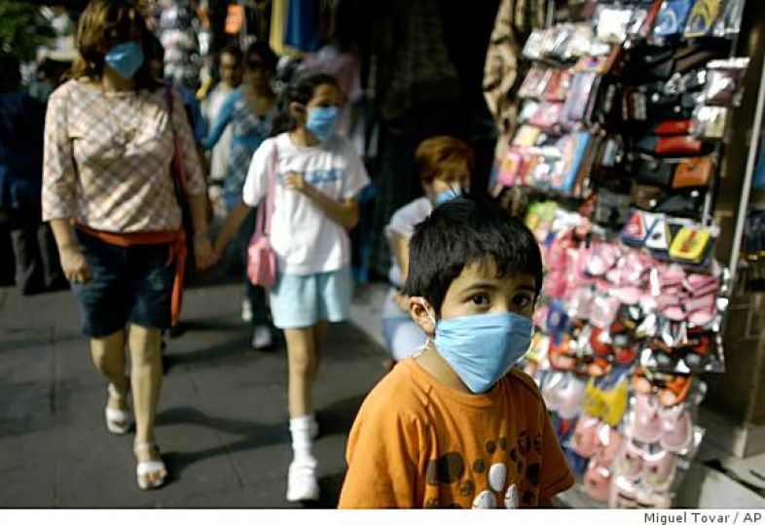
One thing that stands out to Americans in Mexico City are the old VW bug cars that are the taxis. They are usually green like this.
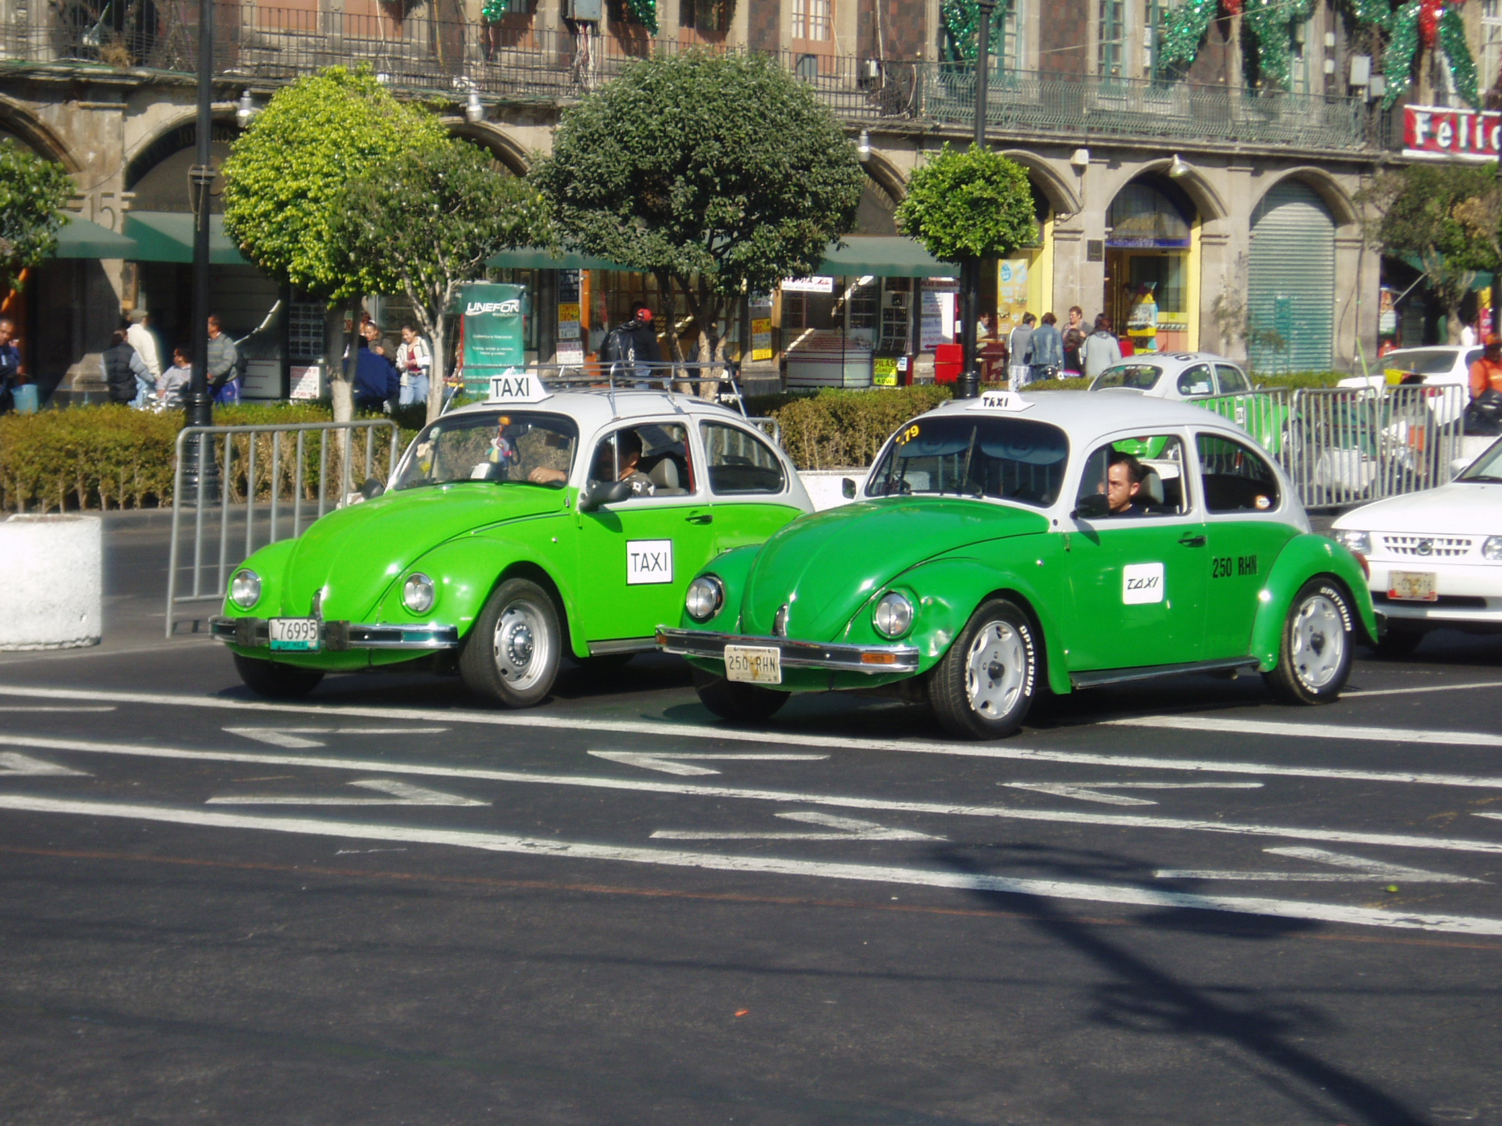

The city is also beautiful with old buildings and some of the best museums and food in the world! In the city there are very rich people and very poor people. Many wealthier people like to escape the city on the weekends to go somewhere more relaxing like nearby Valle de Bravo. The lake there, Lago Avándaro”, is the most popular attraction. There are many water sports available as well as sailboat rides.

If there is time, let the students color a map of Mexico to take home. There is a free one on this site:
http://www.enchantedlearning.com/school/Mexico/Mapprintout.shtml

Cleanup: Give the students a warning to clean up. After 5 minutes all snacks need to be put away. March back to the circle as a class singing the theme song.
XIII. Vocabulary song review: Gather the students back into the circle and teach the following song with gestures. You can reinforce the vocabulary words by holding up the items as you say them. You could replace this with Musical chairs if you prefer.

Me Pongo (Sing to the tune of Farmer in the Dell and sing with gestures of putting clothing items on. It may be really fun to have big size clothes/items that the children can take turns “modeling”)

Me pongo el traje de baño, me pongo el traje de baño
Hoy me pongo el traje de baño (put on swim suit)
Me pongo la toalla, me pongo la toalla
Hoy me pongo la toalla (put towel over shoulders)
Me pongo la proteción del sol, me pongo la proteción del sol
Hoy me pongo la proteción del sol (rub sunscreen on face and arms)
Me pongo los anteojos del sol, me pongo los anteojos
Hoy me pongo los anteojos del sol (put sunglasses on)

*You may also include a verse with ‘la camisa’and ‘las mantas’ from week 1.

XIV. Juego de repasar: Pistas: From all three days so far, choose a variety of flash cards you want to review (about 10). Keep the flashcards and divide the class into two teams: Equipo Dani y Equipo Beto. Line the teams up facing you. Put your vocabulary words in a hat or bag so you can draw blindly. Explain that you are going to give a pista, clue, for the vocabulary word you draw. The players at the front of the line must race to say the word in Spanish. Whoever says the correct word the fastest scores a point for the team. The players then go to the end of the line and the next players in line will be given the next clue. Some suggested clues are listed below. Feel free to add more! Tip: For the younger students, feel free to post the picture flashcards of the possible answers up on the board to help speed up the game and help them reference the vocabulary. *Review the vocabulary words with the flashcards before starting the activity to make sure it is successful.

Sample Clues:
You need me to dry off after swimming. (las toallas)
I am round, usually plastic, and has a hole in the center. (el tubo)
I start the fire with a flash. (el fósforo)
You say this when your tummy grumbles. (Tengo hambre)
Oscar Mayer, Ball Park, Franks (el perro caliente)
XV. Juego de repasar: Telephone-- using Tengo or Necesito. Have students sit down one behind the other in two or three teams, depending on the size of your class. You whisper a short phrase like, “Tengo calor” in the ear of the first child in the line and they have to repeat the word down their line to the last student. When the teams are done, the last student has to say out loud what the phrase was. (Alternate games: mata la mosca or the eliminator game from the previous week.)
XVI. Wrap up: Get out Dani and Beto and explain that they had a lot of fun eating at the campire today, but they are tired and need to go to sleep. Have all of the students say, ¡Adíos! to Dani and Beto.
**Last 5 Minutes of Class: It is VERY important that the last 5 minutes of class be organized. This is most likely the only part of your class that parents will see.

Ending routine:
-Have the students grab their backpacks and return to the circle on the floor. At this time you can distribute newsletters (on colored paper) and the optional homework.
-Show the parents at the door something the kids learned. A great way to end is for each student to tell you a “word of the day” using a builder phrase from this or last week. For example, “Tengo calor” or “Necesito la pelota”
-Teach the goodbye song standing and with gestures.

Filing out:
-Stand at the door and have the class stand in a single file line. Do not let anyone get ahead of you. As the students see their parents, greet the parents and introduce yourself.
-Say good bye and thank you in Spanish as each child is matched with a parent.
-Walk the kids who are in after school to designed after school location
-Return to your room to clean up.

Remember, YOU are the face of Futura in the classroom- thank you for making this a great class!

* The Teacher can have an “alternate” way to sing the class theme song-like a chant for example. Especially for older students, this can be a make-it or break-it first impression of the class!
A fun alternative is to teach it as an interactive chant.
For example:
Teacher: Vamos a…
Students: Acampar!
Teacher: Vamos a…
Students: Acampar!
Teacher: Con
Students: MIS AMIGOS
ALL: Voy - a Acampar!

