Vamos a Acampar Abbreviated Lesson Plan: Day 7
7 Target Vocabulary: La cueva
una cueva | cave | el casco | helmet
las cuerdas | ropes | las rocas | rocks
el autobús | bus | Mi actividad favorita es… | My favorite activity is…

Builder phrases to emphasis: Hay_____ Necesito_____
Materials needed: Flashcards (2 sets from this week) with the target vocabulary; As many real props as possible! Also, bring objects and flashcards from previous lessons that you plan to review. For Day 7, you can bring a helmet and rocks and a rope(s). You can also plan on bringing the big pictures of the bus and cave fro the intrant to make the theme come alive taped in different locations in the room. . Be sure to have your puppets and an ability to play music. You should also prepare for the Notas Culturales and have an ipad or your video available for example to show a video of the cave. See below for descripton. Backpack and flashlight (optional)
You will also need: Two bags for the packing race game. Have fly swatters or have the roca images ready for the juegos. See below for descriptions.
You: Early and prepared with items you need lined throughout the class lined up in order. This class has games that require you prep the classroom.
Vobulary Instruction Methodology: TEACH the vocabulary; REINFORCE the vocabulary; CHECK IN for vocabulary retention.
I. Have Spanish music playing as the students enter the room.
II. Greet each child as they enter the room. ¡Hola! ¡Bienvenidos! Ask them their names in Spanish and mark it on the attendance document. Have each child respond in Spanish to this question. Remind all students to get a drink or go to the bathroom if necessary. (Follow up on attendance as needed)
III. Have the class sit in a circle on the floor, and greet everyone with a lively ¡Buenas tardes clase! Teach ¿Cuántos años tienes? and practice having the kids answer with Tengo ___ años . You can do this by asking each child with a fun plastic microphone.
IV. Stand and sing your chosen greetings song using gestures (Ex: “Hola amigo, ¿Cómo estás?...”)
V. Sit back down in the circle
VI. Review the rules by having the class participate in saying each rule.
VII. Remind everyone that they currently have three estrellas and that if they have all three estrellas by the end of class they can get a sticker or a peso. (*Be sure to have a system to save the pesos or track them. Also, it is a good idea to have a collective place for the students to collect stickers like a name tag, folder, or pre-designed certificate.)
IV. Bring out Dani and Beto and ask the students in Spanish if they remember their names. Encourage them to greet them with, “¡Hola Dani y Beto!”
V. Remind the students that Dani and Beto are camping (a acampar). Have the class say with you, “¡Vamos a acampar!”
VI. Theme song: Stand and sing the theme song with gestures*.
Vamos a Acampar (Sing to the tune of the Farmer in the Dell)
Vamos a Acampar
Vamos a Acampar
Con mis amigos, voy a acampar

VII. Review the vocabulary from last week by pulling out the puppets and the image of Ana María.
Teacher: ¿Clase, recuerda todas las aventuras con Ana María? Class, do you remember all of our adventures with Ana María? Encourage the students to share what they remember from the past two weeks with Ana María. Praise them for participation.
Beto: Conocimos en el parque de la cascada. We met at the waterfall park.
Dani: No olvides que la semana pasada fuimos en la canoa. Don’t forget that last week we went canoeing.
Ana María: Fue bien divertido. It was so fun!
Teacher: Let’s review some of the vocabulary we learned in previous weeks by having a dance party with Ana María before she needs to leave.
Juego de repaso: Baile-Put on music in Spanish and have the students start dancing. When you pause the music whoever moves must answer a word in Spanish.
Alternate-Have the students pretend to hike around the room by marching when you shout, “¡Basta! They must freeze and then proceed like the dance freeze game. Hold up the corresponding flashcard and have all the students repeat.
Canción: If you taught the Vamos a la caza de oso this is a perfect time to sing it.

VIII. Teach the new vocabulary: Gather the students back into the circle with the puppets.
Betoi: Estoy triste que Ana Mar¡a salió. I am sad that Ana Maria had to leave.
Dani: Sí yo sé pero tengo una aventura nueva para nosotros. I know, but I have a fun new adventure planned for us!
Beto: ¿Qué es? What is it?
Dani:¡Vamos a una cueva! We are going to a cave!
Hold up the image for cave and have the whole class repeat la cueva.
Teacher: ¡Vamos a la cueva clase! Have the whole class stand up and walk to the image of the bus you have posted. Vamos por el autobús. Ask the students if they can guess what that word means and then have everyone repeat it together. Then pretend to board the bus. ¡Vamos a la cueva por el autobús. That’s a whole sentence in Spanish! Ask the class to tell you what it means.
Then move to the part of the room where you have the picture of the cave by pretending to be riding on the bus.
Estamos en la cueva. We are at the cave. Clase repite, la cueva. Have the class sit down as you introduce the other words. Necesitamos muchas cosas para entrar la cueva. We need a lot of things before we can enter the cave.
Necesito el casco (Hold up the helmet and have the kids repeat. ) Also, encourage them to tell you what Necesito means.
Necesito las cuerdas. Hold up the ropes and have the students repeat the words several times.
Hay muchas rocas. There are a lot of rocks. Point to the rocks and have the students repeat this word. Tell them what hay means and have them repeat.
*Review the word for bag by also adding to the mix if you wish.

IX. Reinforce the vocabulary: Hold up every object and have the kids repeat the words again. Do the same thing with all the flashcards now also incorporating cueva and autobús this time.
IX. Check in to see if the kids know the vocab: Lay out the objects/flashcards. (You can include the items from last week too.) Call out a vocab word in Spanish by saying the builder phrase Necesito+ the object and have volunteers point to the corresponding object. Alternatively, you can hold up the objects/cards and have the students say the words when you ask ¿Qué necesito? and they answer Necesito + the object. This is a very important step before moving to a game.

X. Juego- Packing race. (You need two sets of flaschards and two bags. )
Explain that Dani and Beto are racing eachother to get to the cave. They need to pack up as quickly as possible. Divide the class into two teams. Have them sit in lines. (Be sure that students of similar age or ability are sitting to compete against eachother.) Have the flaschards in piles in front of the line and the bags at the end. When you call out a word the students must race to grab the corresponding flashcard and pack it into the bag. The students then go to the end of the line and two more students are called. You can add past vocabulary as you see fit.

Alternate juego: Divide the class into two teams. Have the teams sit together so that the class forms a u on the carpet. Put the objects and/or flashcards into the center of the “u”. Call on one team member from each team . (Be sure that students of similar age or ability compete against eachother.)You will call out a word and the students must race to grab the word or object. Whoever does it first scores a point for their team. Have the whole class repeat each word for reinforcement. You can add past vocabulary as you see fit.

XI. Juego: Around the world.
Quickly review vocabulary from the various lessons you want to incorporate including this week by holding up the flash cards/objects and having the class repeat the words in Spanish out loud together. Then divide your class into two teams, Equipo Dani and Equipo Beto. Call one person from each team up to the front of the room. Hold up a flash card with one of the vocabulary images. Whichever player says the word in Spanish first scores a point for his or her team. That player remains at the front and the “losing team” sends another player to compete against the winner. The winner stays in place until he or she gets a vocabulary word incorrect. Keep playing for 5-7 minutes or the winning team scores ten points. You can add an element of fun by having the player who is guessing ring a bell, shake a maraca, or press a buzzer. (To go with the camping theme you can even have a flashlight the student needs to pick up and shine to answer!)
**It is very important that students of the same age and ability compete to start.

Alternate juego: Roca caliente. Have the class sit in a circle on the carpet. Explain that the rocas son muy calientes arriba de la cueva. Explain that rocks on top of the cave are very hot! Dani and Beto need to get past them to get inside the nice cool cave. You are going to help them out! Start music and have the class start passing the rock. (Be sure to have ground rules so they do not throw the rock!) When the music stops whoever is holding it must answer a question in Spanish about the vocabulary. Be sure to then have the entire class repeat the words for reinforcement.

XII. Merienda Y Notas Culturales: 5 minutes max. Have the students get their snacks and go sit at the table quietly while you teach the culture portion of today’s class. Remember this cultural part is not optional!
Ask the class if they remember what country Dani and Beto are from. Bring out the map or globe and have a student identify Mexico on the globe. Remind them that one of the most popular places para acampar en México es la Huesteca en el estado de San Luis Potosí. There is una cueva there called Sótano de las Golondrinas, which means "Basement of the Swallows" in Spanish.
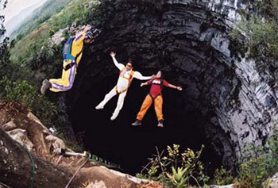 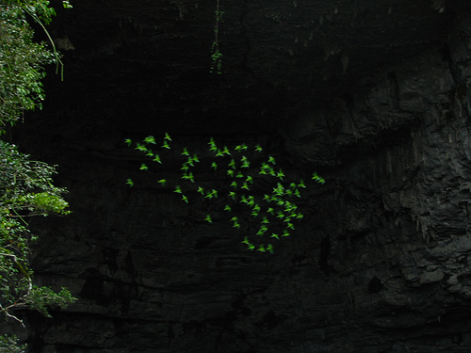
They call it this because the cave is home to many birds and it is a very deep pit, like a basement. Believe it or not, this cave is one of the most famous caves in the world! It has the second deepest entrance drop -Over 1,200 feet! The cave entrance is small so it takes about two hours to enter it. Also, there is something a little bit "yucky" about this cave. The "floor" is covered with "dung" from the millions of birds. There are also millipedes, scorpions, and snakes in the cave! It is recommended that anyone that enters wear a mask. At dawn thousands of birds come out from the bottom of the cave and take over the sky of La Huasteca. At dusk the same thing occurs again when all the birds return to their cave home. There are a lot of people that travel to this cave for extreme or adventure sports like parachuting. Can you believe someone has even landed a hot air balloon inside the cave?! Wow! Dani and Beto better be prepared for a big challenge! Ask your students if they would like to visit Sótano de las Golondrinas someday and why or why not? (Use the pictures from the intranet. If you can it would be great to bring in a laptop and show some of the great movie clips that are on You Tube. This would really make this lesson come alive!)
Alternately or if you have time: You can talk about the very unique enchilada dish that is just from San Luís Potosí in Mexico called Enchiladas Potosinas. Ask if anyone knows what enchiladas are that they have tried the? These enchiladas are different in that they don’t have cheese on the outside and instead of having rolled up tortillas they are more folded over like a pocket.
See the difference? You can hand out the recipe to the students to share with their families:
http://www.food.com/recipe/enchiladas-potosinas-437359
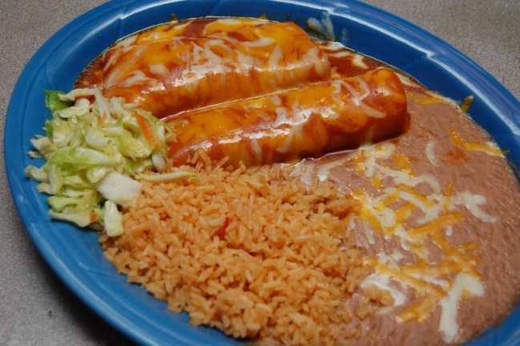

Cleanup: Give the students a warning to clean up. After 5 minutes all snacks need to be put away. March back to the circle as a class singing the theme song.
XIII. Juego Cave walk: Have paper cut out llike stones with the pictures of the vocabulary words on them and lie them around the room in a circle. Explain to the class that you are going on a cave walk in Spanish and then say ¡Vamos! Have them all stand on una roca and then start the music and have them walk slowly and carefully from rock to rock like they would in a slippery cave. When you pause the music they must stop on whichever roca they are on. Call out of a vocab word in English. Whoever is standing on that word must say it in Spanish back to you. Have the entire class repeat and then put the music back on and keep playing.
Alternate juego: Mata la mosca. Explain that Dani and Beto keep getting bothered by flies in the cave and so they brought out their flyswatters! Lay out all the vocab images or tape them to the board. Divide the class into two teams and have one player from each team come up and hand them a fly swatter. Callo ut a Word in Spanish. Whoever swats it first scores a point. Tips: Have students of corresponding level and age compete; have the class repeat each Word for reinforcement.
Quiet Activity Mi actividad favorita es… : Use the puppets to make sentence with Mi actividad favorita es…. Then give an example from this or previous weeks. Write on the board some of the activities from this and previous weeks as you take examples from volunteers. Then hand out the Mi actividad favorita es… sheet from the intranet and have the students write out their favorite activity. After they are done writing they can draw a picture. If there is time they can come up to the front of the room and introduce their paper speaking all in Spanish!
XVI. Wrap up: Puppets’ Despedida Gather the students back into a circle on the floor and pick up the puppets.
Beto: La cueva fue bien divertido. The cave was so fun.
Dani: Sí pero tengo sueño. Yes, but I´m tired (yawn)
Beto: Yo también. Me too.
Dani: Buenas noches Beto. Goodnight Beto.
Beto: Buenas noches, Dani. Goodnight Dani.
Encourage the class tos ay Buenas noches and explain what it means.

**Last 5 Minutes of Class: It is VERY important that the last 5 minutes of class be organized. This is most likely the only part of your class that parents will see.

Ending routine:
-Have the students grab their backpacks and return to the circle on the floor. At this time you can distribute newsletters (on colored paper) and the optional homework.
- A great way to end is for each student to tell you a “word of the day” using a builder phrase from this or last week. For example, Necesito el casco.

-Sing the goodbye song standing and with gestures.

Filing out:
-Stand at the door and have the class stand in a single file line. Do not let anyone get ahead of you. As the students see their parents, greet the parents and introduce yourself.
-Say good bye and thank you in Spanish as each child is matched with a parent.
-Walk the kids who are in after school to designed after school location
-Return to your room to clean up.

Remember, YOU are the face of Futura in the classroom- thank you for making this a great class!

