¡El autobús!

Directions: Unscramble each word in Spanish. If your child does not yet read, use the word bank for clues. When you are done filling in the blanks, practice saying each word.

Word bank: ciudad, pasajeros, parada, monedas, conductor

E D M A O S N _____________________________
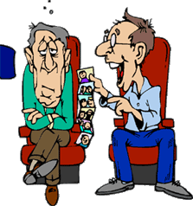 O R A S J S A P E ____________________________
C T U O N R O D O _____________________________
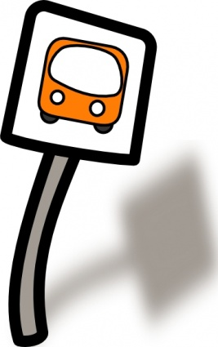 A D R A A P _____________________________

BONUS question! Use the builder phrase, “tengo” from this week’s newsletter to translate this sentence into English:

Tengo las monedas. = ____________________________

Note to parents/guardians: One of the pieces of language acquisition is spontaneously saying words. Therefore, at this stage it’s important to use both the the word bank and images to jog the students' memories from class instruction.

