Day 4- Optional Homework
Directions: Label the matching adjective for the images below using the Spanish vocabulary below. Use your newsletter for help.
Tip: Remember that when the person being described is a male the adjectives end in “o” and when it is a female they end in “a.”
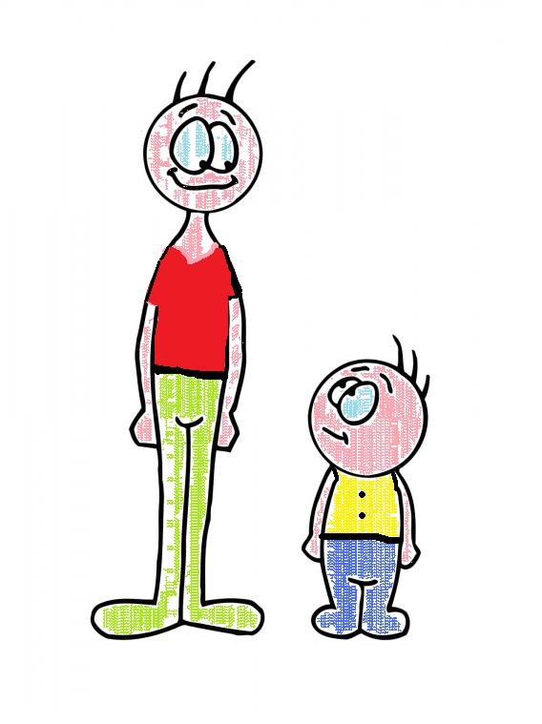
alto(a), bajo(a), amable, caro, barato, hermoso(a)

_____________

__________ __________

_____________
_____________ ______________
Extra: In Spanish, adjectives come after the noun, instead of before the noun in English. Practice this by writing the following translations.
For example: inexpensive skirt= falda barata

- Nice male cousin = ___________________.

- Beautiful aunt=_________________.

- Short female cousin= _________________.

