Day 8- Optional Homework
¡Vamos a la playa! Let’s go to the beach!
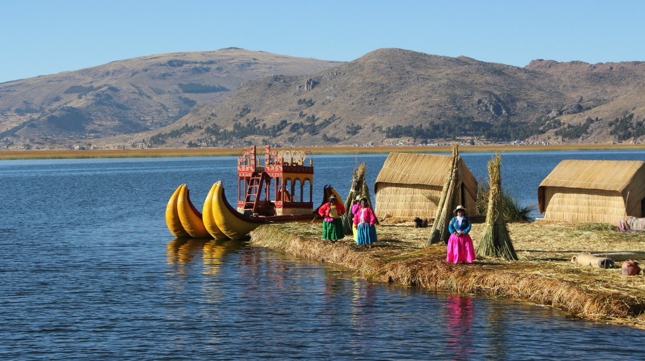
Directions: Draw a picture of a family at la playa (the beach) visiting Lake Titicaca in Peru. Label each family member in Spanish using the word bank. ¡Gracias por un semestre tremendo! Thank you for a tremendous semester!
la mamá el hermano la hermana el abuelo la abuela
el papá el primo la prima el tío la tía

