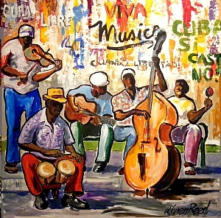
¡Los músicos en la calle!

Directions: Think back to today’s adventure: the musicians in the street. Unscramble each word to complete the sentence in Spanish. If your child does not yet read, use the word bank below to complete the sentence by looking at the picture for clues. When you are done filling in the blanks, practice saying each sentence and translate it into English. The builder phrases are: Toco ____. (I play ____) and Me gusta ____. (I like ____)

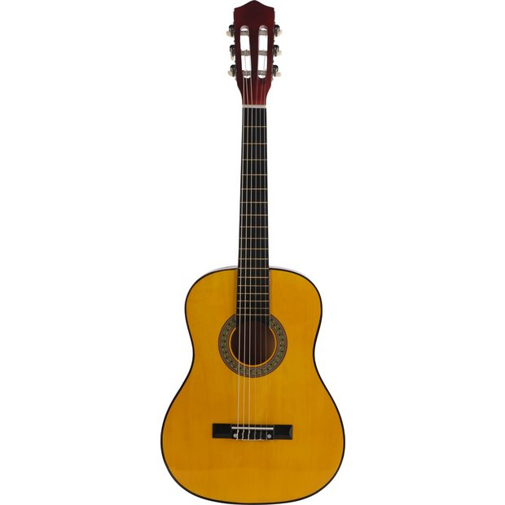 R R U I A G A T Toco la ______________________________.

O P A O U S L A Me gusta el ____________________________.

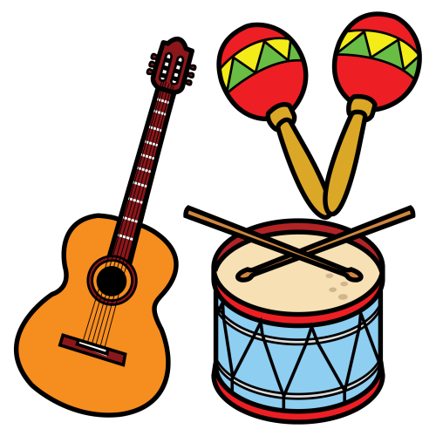 N I S M O T T U E R S N Toco los ______________________________.

D A A B N Me gusta la ______________________________.

O D G G M I N O Toco el __________________________.

Word bank:
la banda, los músicos, los instrumentos, la guitarra, el aplauso, el domingo.

