Nombre:________________________
TOTAL: _____/30
PERCENTAJE: ____%

El Proyecto A: Mi Ciudad
You will be creating your own city map!

The map must include the following:
- A name for your city in Spanish
- 10 or more places labeled in Spanish (with correct spelling)
- A symbol on each building making the place obvious (cross for the church, etc)
- 3 or more streets with names in Spanish using this format: la avenida __________ OR, la calle _____________)
- Neatly typed or written labels and color drawings or pictures.

El Rúbrico -
The city has a name in Spanish with correct spelling 5 4 3 2 1 0

The city includes 10 or more labeled places 5 4 3 2 1 0

Each place on the map has a symbol 5 4 3 2 1 0

The map has 3 or more streets labeled in Spanish 5 4 3 2 1 0

The project is colorful and neatly completed 5 4 3 2 1 0

Spanish spelling and grammar is correct 5 4 3 2 1 0

Total: /30

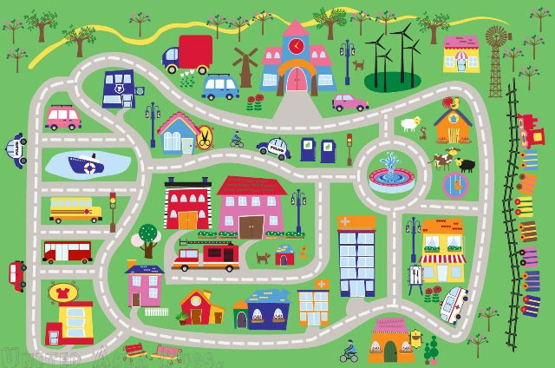
Comments:
