Práctica II: Agreement Nombre:_____________________________

Make the adjectives agree with the person/people listed in each section.

1. Ana es…
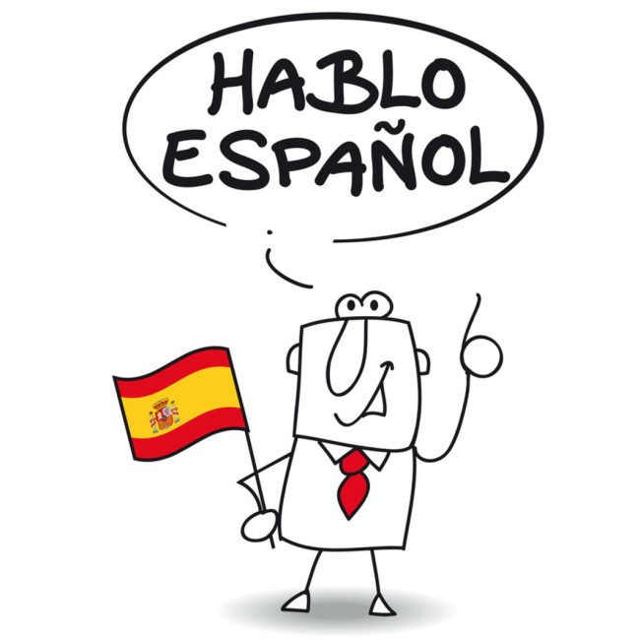
  - pretty___________________
  - generous_____________________
  - intelligent____________________
  - funny_______________________

2. Luis y Carlos son…
- lazy _______________________
- fun________________________
- mean_______________________
- short _______________________

- Vosotras sois…
  - red-headed_______________________
  - organized_________________________
  - medium-height_______________________
  - interesting_________________________

- Juanita y Juan no son…
  - nice________________________
  - timid________________________
  - hard-working_______________________
  - old __________________________

