C. Los Colores and Agreement
Los colores: Student Resource Page for Colors
Target Vocabulary and Concepts
rojo/a | red | blanco/a | white
anaranjado/a | orange | negro/a | black
amarillo/a | yellow | gris | gray
verde | green | marrón | dark brown
azul | blue | castaño/a | brown (chestnut)
morado/a | purple | rosado/a | pink

Grammar Tips
Colors can be nouns, such as in “My favorite color is blue.”
Mi color favorito es el azul.
- When used as nouns, colors will always use the article __el___.

Colors may also be adjectives, such as in “I have a blue notebook.”
Yo tengo un cuaderno azul.
- When they are adjectives, they will usually go __after__ the noun.
- When they are adjectives, they must be made to agree in __gender__ and __number__.

Watch the order, and watch for agreement. The first one has been done for you.
- two red books = dos libros rojos
- one brown chair = una silla parda/marrón
- six green pencils = seis lápices verdes
- three purple pens (plumas) = tres plumas moradas
- eleven orange backpacks = once mochilas anaranjadas
- thirteen black cats (gatos) = trece gatos negros

Nota Cultural: Chichén Itzá
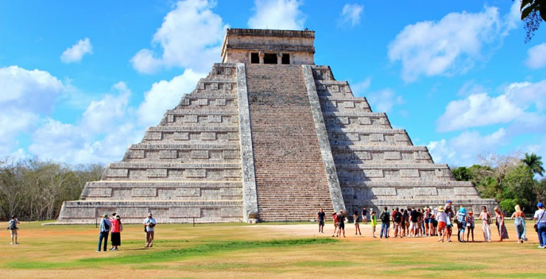
This picture shows part of Chichén Itzá, a Mayan archaeological site in the Peninsula Yucatán in México. Chichén Itzá is one of the most famous sites for Mayan exploration. It was a thriving city from about 600 B.C. to 1000 A.D., and archaeologists have found many fascinating artifacts from that period. Some of their finds include jade pieces, a sacred well, a palace, a stage, a huge temple (shown above), and the ball court, from which the drawing on your quiz was taken.
The Mayan ball game is something about which anthropologists and archaeologists are still trying to learn more. Imagine one long green court with walls of stone running the length of it. High up on the side wall, you spy a stone circle, covered in carvings. The point of the ball game was to get the ball through the hoop, but players were not to touch the ball with their hands. In that way, it was a bit like soccer. The ball game was supposed to mimic the movement of the sun through the heavens.
One interesting detail that has researchers wondering about some of specifics of the game is the carving on the walls of the court. Among many other pictures, you can see warriors being beheaded. No one is totally sure if these were the winners of the ball game or the losers. In Mesoamerican cultures (that’s Mexico and Central America), some groups practiced human sacrifice. Although it was almost always prisoners of war who were used for sacrifices, it was considered an honor to be sacrificed to the gods and some researchers believe that being sacrificed was a privilege for the winners.
Archaeologists are still learning more and more about Mesoamerican cultures, in part through working on huge restoration projects at sites like Chichén Itzá. Archaeologists take all the fallen pieces and try to reconstruct the buildings like a puzzle, except without a picture to guide them. Who knows…maybe someday you’ll have the opportunity to see what they’ve done so far in the Yucatan Peninsula in México!

