Proyecto- Present Progressive – Page 1 Nombre:___________________________
Pretend you are visiting a Spanish-speaking country! Create a postcard describing your travels.
Country List
Puerto Rico
Cuba
Chile
Argentina
Bolivia
Paraguay
Colombia
Panamá
Guatemala
Costa Rica
España
El Salvador

- Choose one of the countries from the Country List box.
- Write a postcard to a friend or family member discussing what you are “doing” in that location, using and
underlining at least 4 sentences in the present progressive.
- Find or draw the flag of your country and use it for your stamp.
- Include a greeting using “Querida /Querido” as well as a closing such as “con amor.”
- Research a popular tourist destination in the country you choose.
- Find a color photo or draw and color the tourist destination on the back of the postcard and include a sentence or
two describing the location in English (or Spanish).
- Practice and be ready to present your postcard to the class.
Querida abuela,  Estoy viajando en Perú con mi amigo, Carlos. Nosotros estamos visitando Machu Picchu. ¡Es increíble! Estamos subiendo las montañas y estoy comiendo muchas empanadas.  Con amor,  Luis | Marta Smith  2352 South Street  Madison, WI 53590  U.S.A.
- Be sure to double check your work using the Rubric on the backside of this paper.
Example:

Machu Picchu, Perú
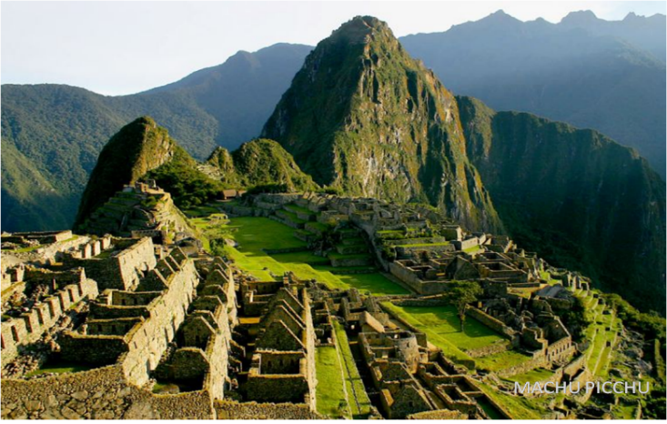

The Incan ruins of Machu Picchu is one of the seven natural wonders of the world. The ruins are located in the Andes mountains at almost 8,000 feet above sea level.
Rough Draft Due:______________

Final Draft Due: _______________

