**Práctica II: (Use the Student Resource-Page 1 for spelling)**

Write the infinitive reflexive verbs in Spanish that best represent the pictures below.

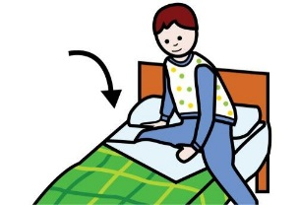

1. **_______________ 5. ________________ 9. _________________**

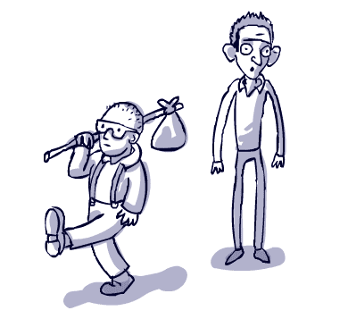

to enjoy oneself

 **2. ________________ 6. _________________ 10. _________________**

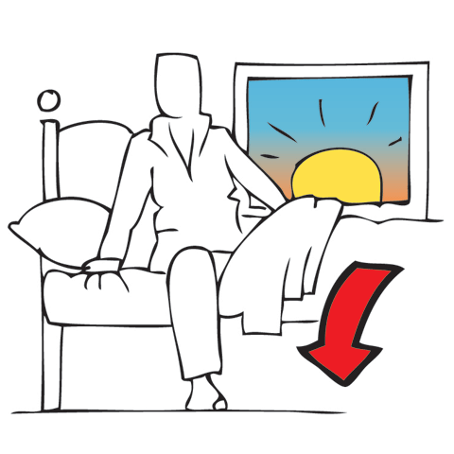

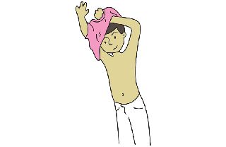 **3. ________________ 7. _________________ 11. __________________**

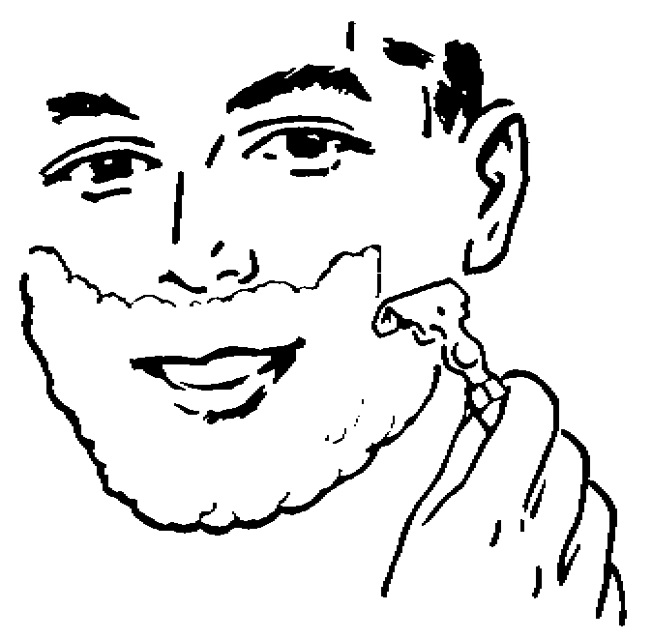

to wake up

**4. ________________ 8.__________________ 12. _________________**

**What is a reflexive verb?**

**What’s the difference between reflexive verbs and regular verbs?**