Práctica III: Conjugating Regular Reflexive Verbs
Part I: Fill in the chart with the Reflexive Pronouns:
yo |  | nosotros/as
tú |  | vosotros/as
él  ella  usted |  | ellos  ellas  ustedes
Part II: Use the chart above and follow the steps to conjugate the following verbs.
Modelo- She combs (herself). peinarse/ella Ella se peina.
1. They brush. cepillarse/nosotros ____________________________________________
- He bathes. bañarse /él __________________________________________________
- You all shower ducharse/Ustedes ___________________________________________
- I look at myself mirarse/yo _______________________________________________
- You prepare yourself. prepararse/tú _________________________________________
Part III: Fill in the blanks using a reflexive pronoun and verb that correlates with the picture and sentence.
Tú _______ ____________________ los dientes.
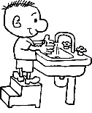
- Nosotros _________ ______________________ las manos.
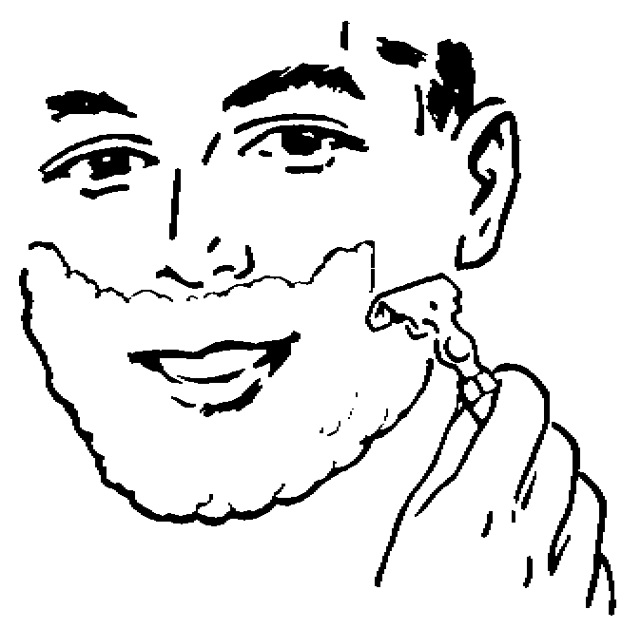
- El padre _________ ________________________ la cara.
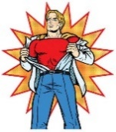
- María Luisa _________ _______________________ la chaqueta.

