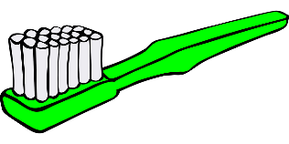**Práctica I: Más Vocabulario** (Print this page on dark colored paper) **Cut apart the squares and write the vocabulary word in Spanish on the back to create flashcards.**

|  |  |  |  |
| --- | --- | --- | --- |
| Image result for bed clip art | Image result for hair dryer clip art | Image result for alarm clock clip art | Image result for bathroom clip art |
| Image result for hair brush | Image result for comb | Image result for soapclip art | Image result for towelRelated image |
|  | Image result for clothing clip art | Image result for toothpaste |  |
| Image result for mirror | Image result for shampoo | Image result for make up clip art | Image result for bathtub clipart |