Práctica A- Reflexivos
Mira los dibujos. Escribe 10 frases usando los reflexivos y la hora.
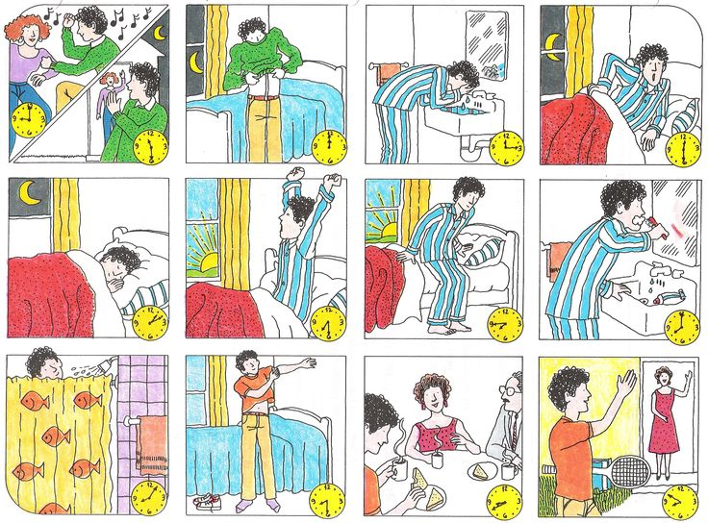

1.______________________________________________________________________
2.______________________________________________________________________
3.______________________________________________________________________
4.______________________________________________________________________
5.______________________________________________________________________
6.______________________________________________________________________
7.______________________________________________________________________
8.______________________________________________________________________
9.______________________________________________________________________
10._____________________________________________________________________

