Práctica V: Use the picture clues to create a sentence. Include a verb, the object and the time.
Hints: con = with, a las = at _______, en = in
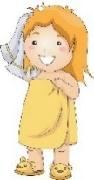
1. Marta_______________________________________________________________
5:45

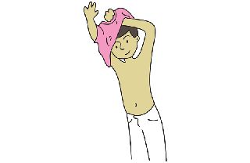
2.
Yo_______________________________________________________________
8:10
3. Carlos y yo____________________________________________________________
6:30

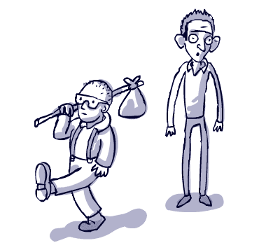
4. Las muchachas___________________________________________________________
7:50
5. Tú ______________________________________________________________
10:15

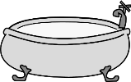
6. Vosotros__________________________________________________________
9:55

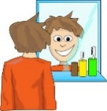
7. Ustedes_______________________________________________________________
1:00
8. Ana _________________________________________________________
2:20

