Nombre: _____________________ Fecha: ______________

Directions: Use the word bank to label the weather illustrations in Spanish below.

hace sol llueve temperatura

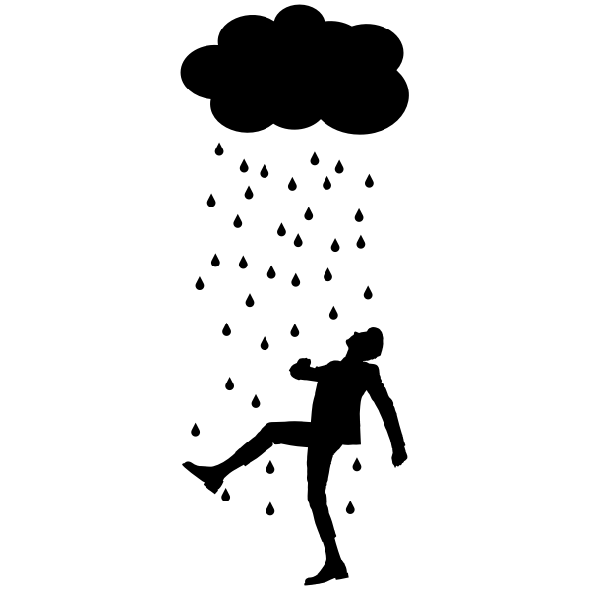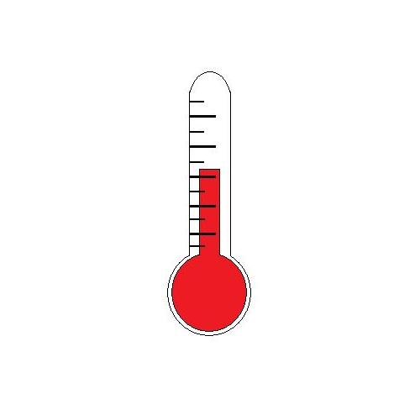

___________________ _____________________ ___________________

Directions: Cierto o Falso (true or false). Circle cierto for true and falso for false for the sentences below.

- Está nublado means it’s windy in Spanish. Cierto Falso
- Hace frío means it’s cold in Spanish. Cierto Falso
- Tiempo means temperature in Spanish. Cierto Falso
- Hace calor means it’s hot in Spanish. Cierto Falso
- Grados means degrees in Spanish. Cierto Falso
- Nieva means cloudy in Spanish. Cierto Falso
- Hace viento means it’s cloudy in Spanish. Cierto Falso

