SEMANA (week) | FECHA (date)
Semana 2

- Gramática (Grammar): Los pronombres (the subject pronouns)
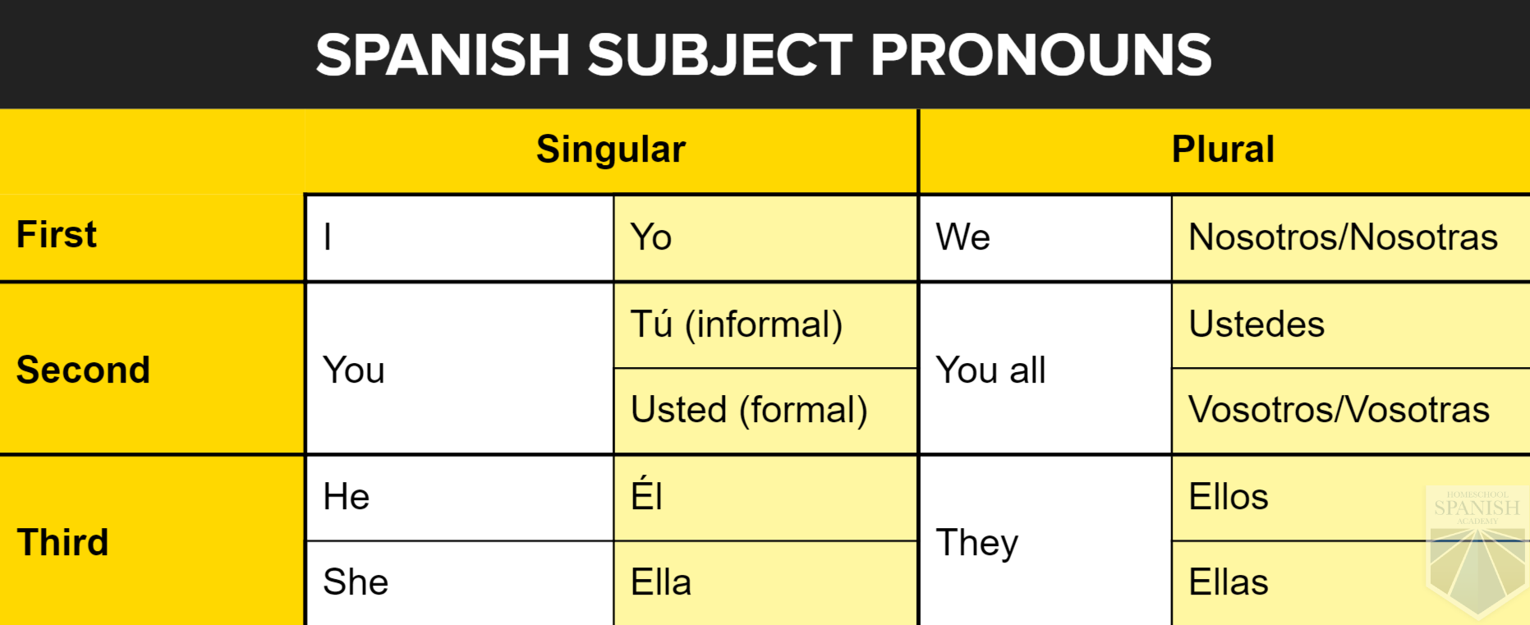
- Tu (You informal) is used for people you have confidence or your same age
- Usted (You Formal) for people older than you or to show respect (your doctor, a priest, your boss, etc.)
- Ellos is used for: They boys and They boys and girls
- Ellas is used just for they girls

- Conversation: Say which subject pronouns will correspond to:

- Elisa & Mathiew ---- Ellos
- Myself ------ Yo
- Alicia & me ------ Nosotros
- Tom & Allan ------ Ellos
- Your sister ------ Tú
- Jenny & Susan ----- Ellas

3. Verbo ESTAR: Verb TO BE= Yo estoy

Person | Singular
1rst | I am | Yo estoy
2nd | You are | Tú estás
3rth | He/she / You formal /it is | El/ella/ Usted/ésto está
 | Plural
1rst | We are | Nosotros estamos
2nd | You (all) are | Ustedes están
3rth | They are | Ellos están

4. Vocabulary places:

Los Lugares | The Places
- El parque | The park
- El museo | The museum
- La casa | The house
- El hotel | The hotel
- La ciudad | The city
- La tienda | The store
- El restaurant | The restaurant
- El pueblo | The town
- La iglesia | The church
- El banco | The bank
- La calle | The street
- El cine | The movie theater
- La playa | The beach
- El café | The coffee
- El trabajo | The work
- El Doctor | The Doctor
- El aeropuerto | The airport
- El baño | The restroom
- El supermercado | The supermarket
- La estación del tren | The train station

5. Practice: Using subject pronouns & conjugating ESTAR verb

¿Dónde estás? (Where are you)
¿Dónde están? (Where are you all)

- Yo estoy en el aeropuerto (I am in the airport)
- Ellos están en el café (They are in the coffee)
- Ella está en la playa (She is in the beach)
- ¿Estás tú en el trabajo? (Are you at work?)
- El está en la tienda (He is in the store)
- Usted está en la iglesia (You formal are in the church)
- Nosotros estamos en el banco (We are in the bank)
- Ustedes están en el hotel (You all are in the hotel)

