Conversational Spanish for Adults

SEMANA (week) | FECHA (date)
Semana 5

GRAMMAR: ¿El o la? Gender of Spanish Nouns
- Gender can be determined by word meaning. The word for “man” will be masculine; for “woman” will be femenine: El hombre/la mujer. Some words that are otherwise very similar will change the article and sometimes shift slightly in spelling to reflect gender: el estudiante/la estudiante, el profesor/la profesora.
- Languages, rivers, oceans, days of the week and months of the year are masculine
- Often, words ending in d, ión, z and a are femenine. These are sometimes referred to as “DIONZA” (d-ión-z-a) words to help you remember which endings are often (but not always!) femenine. So DIONZA, (d-ión-z-a) endings are Femenine
- Often (but not always!), words ending in “ LONER” (l,o,n,e,r) are masculine. These may be referred to as “loner” words to help you remember the key endings.
So LONER (l-o-n-e-r) endings are maculine
- Remember that definite & indefinite articles (el , la, los las, un, uno, unas, unos, etc) also singular or plural have to match the noun in masculine or feminine. Ej. La casa, las casas, el parque, los parques, etc.

FOOD VOCABULARY and building frases:
Builder frases:
- ¿Cuanto cuesta? How much is it? ¿Cuanto cuestan? Plural
- ¿Que le gustaría para comer? What would you like to eat?
- Me gustaría… I will like… Me gusta I like No me gusta I don’t like
- ¿Tiene? Do you have? Que tiene para….? What do you have for….?
- Que rico! Delicious! Bueno Good Malo Bad (as it refers to food)
- ¿Hay….? Is/Are there any….? ¿No hay? There is not…?
- La cuenta por favor? The check please? Cuanto es? How much it is?
- Precio Price, Costo Cost, Cambio exchange, descuento discount
- Pago en efectivo Pay with cash, Pago con tarjeta de crédito Pay with credit card
- Buen provecho/ Provecho Enjoy your meal.
- Vamos a desayunar, comer, cenar Let’s go to have breakfast, lunch, dinner, Tengo hambre I’m hungry
- Por favor Please, Gracias thank you

Comida | Food
- Desayuno | Breakfast
- Comida | Lunch
- Cena | Dinner
- Bebida | Drink
- Postre | Dessert
- Huevos | Eggs
- Bocadillo/ snack | Snack
- Pan | Bread
- Sándwich | Sandwich
- Papas fritas | Chips
- Papas a la francesa | French fries
- Verduras | Vegetable
- Fruta | Fruit
- Sopa | Soup
- Ensalada | Salad
- Bistec | Beef
- Pollo | Chicken
- Pescado | Fish
- Arroz | Rice
- Frijoles | Beans
- Café | Coffee
- Jugo | Juice
- Cerveza | Beer
- Agua | Water
- Leche | Milk
- Helado | Ice cream
- Restaurante | Restaurant
- Y | And
- Con | With
- Para llevar | To go
- Dolar | Dollar
- Centavo | Cents
- Cambio o feria | Change or money fair

LOS NUMEROS:
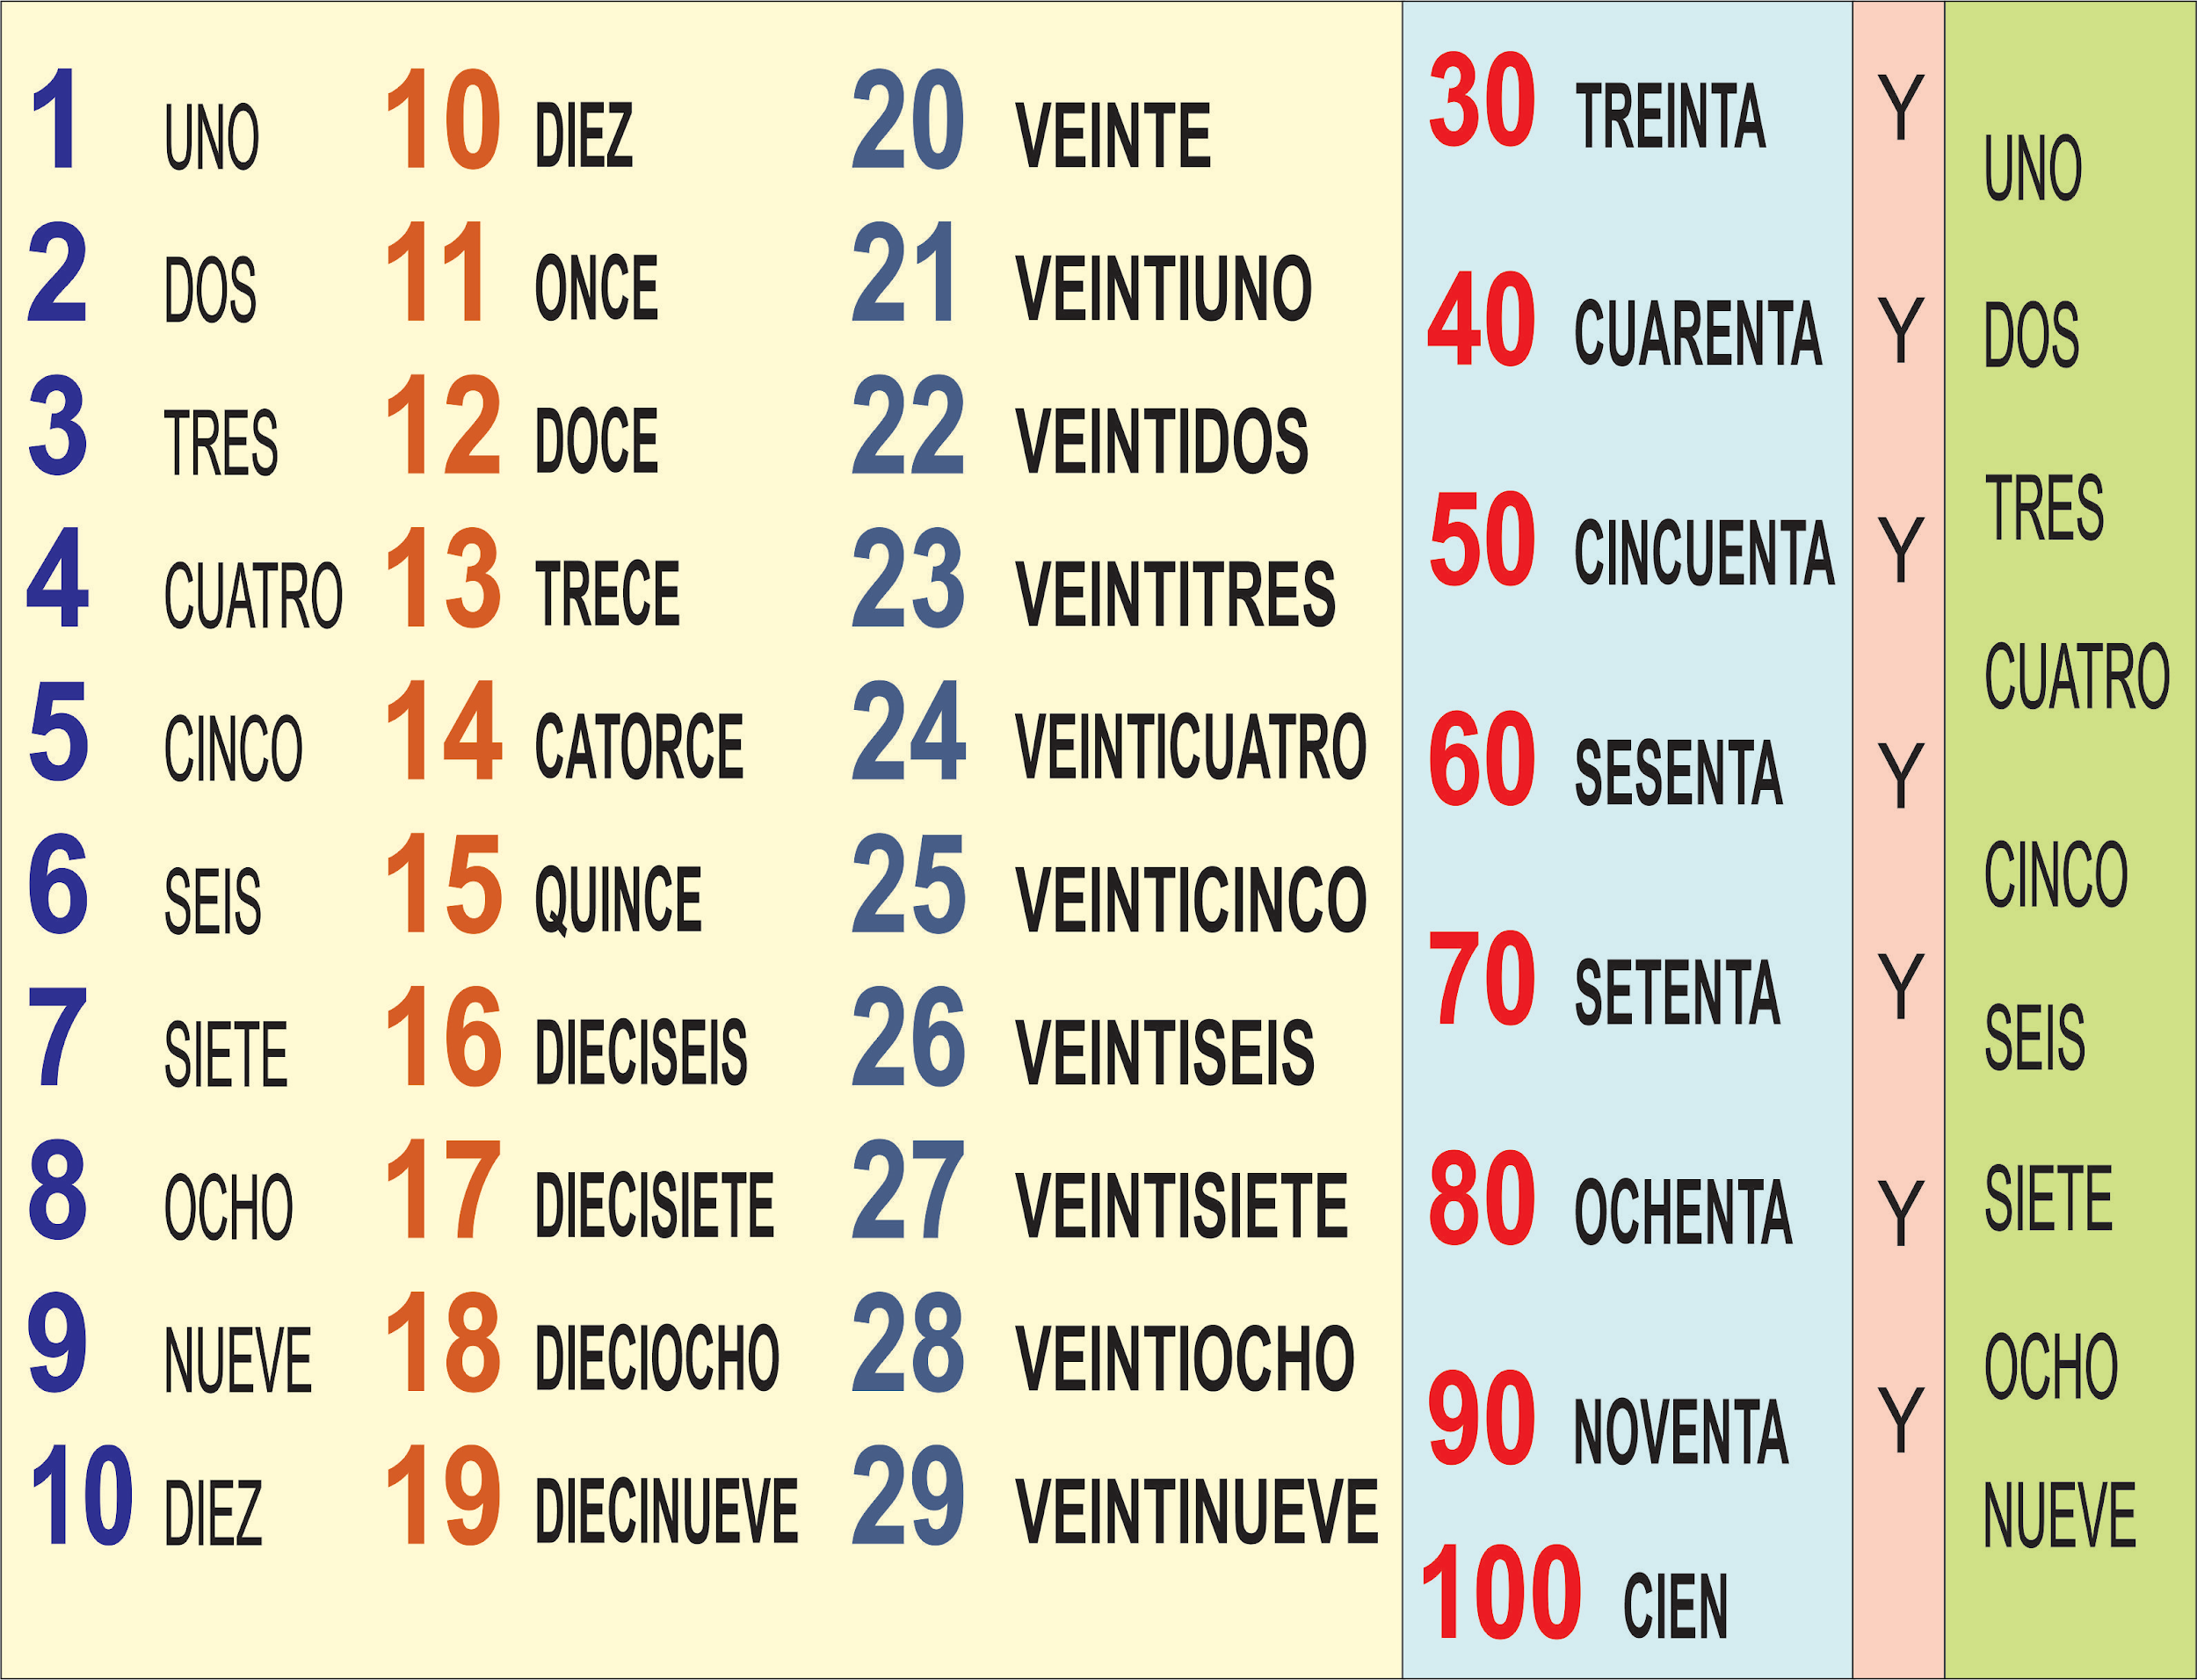

CLOTHES VOCABULARY and building frases:

Builder frases:
- ¿Tiene … en talla....? Do you have….in size….?
- ¿Cuanto cuesta? How much is it?¿Cuánto cuestan? How much are these?
- Grande Large, Mediano medium, Chico small
- ¿Que colores tiene? In what colors do you have? Color color
- ¿Dónde está el probador? Where is the fitting room?
- Me queda ..(chico, grande) It is..(small, big) for me
- Me dá …. Por favor, Give me …. please

La ropa | The clothes
- La falda | The skirt
- La camisa (for men) | The shirt
- La blusa (for women) | The blouse
- La camiseta/ playera | The T-shirt
- La chamarra/Chaqueta (except in Mexico) | The jacket
- Abrigo | The coat
- El vestido | The dress
- El gorro/ el sombrero | The hat
- Los zapatos | The shoes
- Los tenis | Tennis shoes
- Las sandalias | The sandals
- Los guantes | The gloves
- Los pantalones | The pants
- Los shorts (pantalones cortos) | The shorts
- Los calcetines | The socks
- El traje de baño | The swimsuit
- La bolsa | The purse

